

**学校代码：10129**

**系 别：计算机技术与信息管理系**

**年 份：2023**



**Hadoop实训报告**

题 目: 大数据电信客服

专 业: 大数据技术与应用

班 级：20级大数据技术与应用班

学 号：202014224B282

2020142247524

2020142247524

学生姓名：常存金 王慧博 兰翔

职业技术学院计算机技术与信息管理系

2022年12月6日

目录

Hadoop实训（中国电信客服） 3

项目背景 4

开发环境 4

业务流程 5

一.数据生产 5

1.1业务流程 5

1.2创建基础对象接口 6

1.3创建生产者对象 9

1.4获取通讯录数据 15

1.5将项目打包到服务器 23

二.数据消费 24

2.1业务流程 25

2.2配置Kafka 25

2.3初步使用Kafka 27

2.4创建Kafka JavaAPI 30

2.5API结合Hbase 33

2.5.6封装Hbase对象 43

2.6设置过滤 49

2.7协处理开发 50

2.8让表知道协议处理器 56

2.9打包上传测试 58

三.数据分析 60

3.1业务流程 60

3.2MySQL表设计 60

3.3数据计算-启动类 61

3.2数据计算-Mapper 62

3.3数据计算-Reducer 64

3.4数据计算-OutPutFormat 64

3.5数据计算-工具类 68

3.6初步打包测试 71

3.7在OutPutFormat中获取用户和时间数据 72

3.10安装Redis 78

3.11使用Redis保存缓存数据 79

3.12自定义K V 87

四.数据展示 101

4.1创建SpringBoot项目 101

4.2Entity 101

4.3Dao 103

4.4Service 103

4.5ServiceImpl 104

4.6Conteoller 105

4.7查询界面 107

4.8Echarts图例 112

4.9展示 121

# **Hadoop实训（中国电信客服）**

#

## 项目背景

通信运营商每时每刻会产生大量的通信数据，例如通话记录，短信记录，彩信记录，第三方服务资费等等繁多信息。数据量如此巨大，除了要满足用户的实时查询和展示之外，还需要定时定期的对已有数据进行离线的分析处理。例如，当日话单，月度话单，季度话单，年度话单，通话详情，通话记录等等+。我们以此为背景，寻找一个切入点，学习其中的方法论。当前我们的需求是：统计每天、每月以及每年的每个人的通话次数及时长。

## 开发环境

系统：Window11专业版 ContOS7

IDE：IDEA2022.1.4专业版 Maven4.0 JDK1.8

集群环境：

Hadoop 3.3.0

Zookeeper 3.6.3

Hbase 2.4.10

Flume 1.9.0

Kafka 2.12

Redis 5.0.6

硬件：

hadoop101 内存：4GB 处理器：4 硬盘：50GB

hadoop102 内存：4GB 处理器：4 硬盘：50GB

hadoop103 内存：4GB 处理器：4 硬盘：50GB

## 业务流程

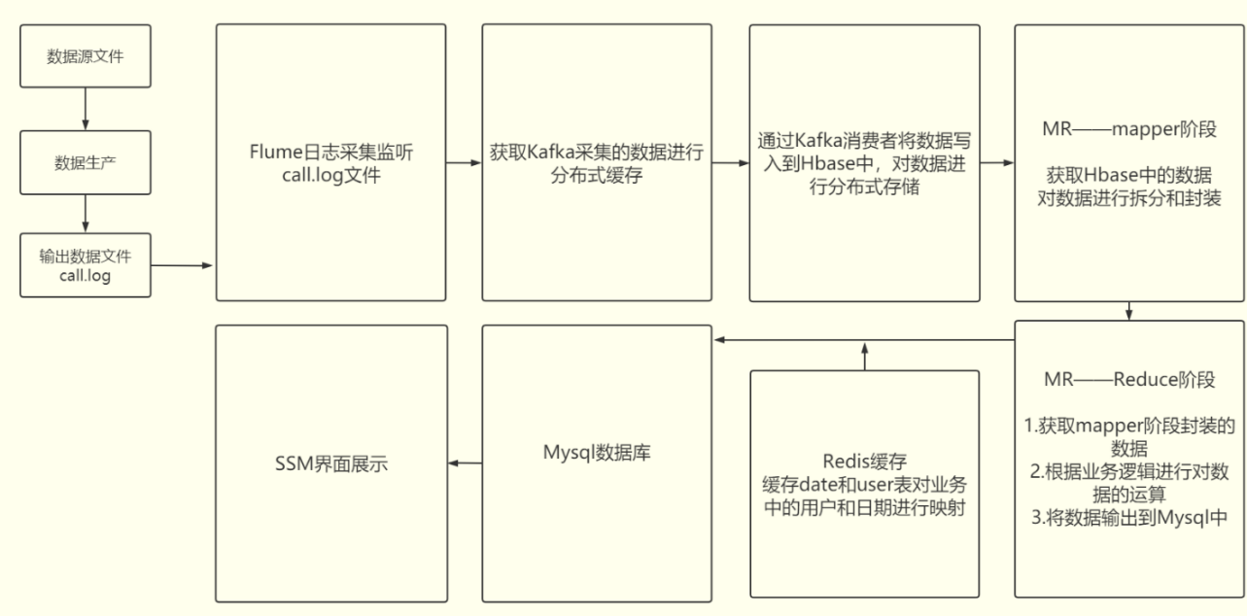

## 一.数据生产

### 1.1业务流程

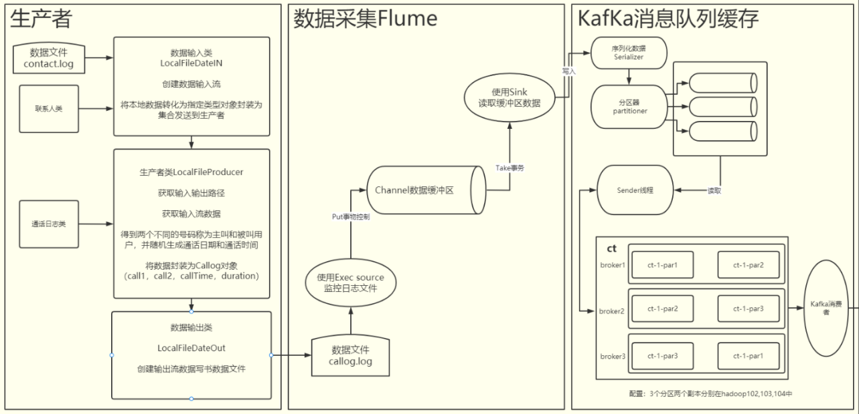

#### 1.1创建Maven工程

创建项目Hadoop_CT 创建项目子模块：ct-common ct-producer

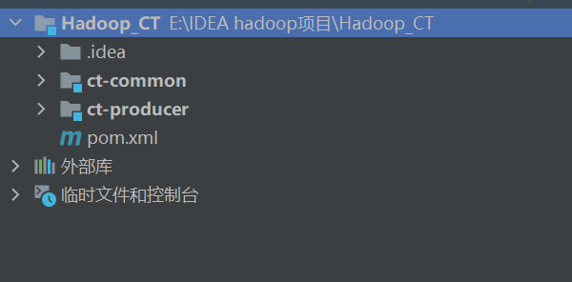

### 1.2创建基础对象接口

#### 1.2.1值对象接口Value

package org.fengyue.ct_web.commom.bean;  
  
/**  
 * 值对象接口  
 */  
  
public interface Value {  
 public void setVal(Object val);  
  
 public Object getVal();  
}

#### 1.2.2生产者接口Produce

package org.fengyue.ct_web.commom.bean;  
  
import java.io.Closeable;  
  
/**  
 * 生产者接口  
 */  
  
public interface Producer extends Closeable {  
 public void setIn(DataIn in);  
  
 public void setOut(DataOut out);  
  
 /**  
 * 生产数据  
 */  
 public void produce();  
}

#### 1.2.3数据接口 DataIn DataOut

package org.fengyue.ct_web.commom.bean;  
  
import java.io.Closeable;  
import java.io.IOException;  
import java.util.List;  
  
/**  
 * 数据来源  
 */  
public interface DataIn extends Closeable {  
 public void setPath(String path);  
  
 public Object read() throws IOException;  
  
 public <T extends Data> List<T> read(Class<T> clazz) throws IOException;  
}

package org.fengyue.ct_web.commom.bean;  
  
import java.io.Closeable;  
  
/**  
 * 数据出口  
 */  
public interface DataOut extends Closeable {  
 public void setPath(String path);  
  
 public void write(Object data) throws Exception;  
  
 public void write(String data) throws Exception;  
}

#### 1.2.4名称枚举类 Names

package org.fengyue.ct_web.commom.constant;  
  
import Value;  
  
/**  
 * 名称常量枚举类  
 */  
public enum Names implements Value {  
 NAMESPACE("ct");  
 private String name;  
  
 private Names(String name) {  
 this.name = name;  
 }  
  
  
 @Override  
 public String val() {  
 return name;  
 }  
}

### 1.3创建生产者对象

#### 1.3.1创建生产者对象类

/**  
 * @Time : 2022/12/3 12:38  
 * @Author : jin  
 * @File : LocalFileProducer.class  
 */  
package org.fengyue.ct_web.producer.bean;  
  
import DataIn;  
import DataOut;  
import Producer;  
  
import java.io.IOException;  
  
/**  
 * 本地数据文件生产者  
 */  
public class LocalFileProducer implements Producer {  
  
 @Override  
 public void setIn(DataIn in) {  
  
 }  
  
 @Override  
 public void setOut(DataOut out) {  
  
 }  
  
 @Override  
 public void produce() {  
  
 }  
  
 @Override  
 public void close() throws IOException {  
  
 }  
}

#### 1.3.2创建本地文件类

/**  
 * @Time : 2022/12/3 12:50  
 * @Author : jin  
 * @File : LocalFileDataIn.class  
 */  
package org.fengyue.ct_web.producer.io;  
  
import Data;  
import DataIn;  
  
import java.io.*;  
import java.util.ArrayList;  
import java.util.List;  
  
/**  
 * 本地文件输入  
 */  
public class LocalFileDataIn implements DataIn {  
  
 private BufferedReader reader = null;  
  
 public LocalFileDataIn(String path) {  
 setPath(path);  
 }  
  
 @Override  
 public void setPath(String path) {  
 try {  
 reader = new BufferedReader(new InputStreamReader(new FileInputStream(path), "UTF-8"));  
 } catch (FileNotFoundException | UnsupportedEncodingException e) {  
 throw new RuntimeException(e);  
 }  
  
 }  
  
 @Override  
 public Object read() throws IOException {  
 return null;  
 }  
  
 /**  
 * 读取数据返回数据集合  
 *  
 * @param clazz  
 * @param <T>  
 * @return  
 * @throws IOException  
 */  
 @Override  
 public <T extends Data> List<T> read(Class<T> clazz) throws IOException {  
  
 List<T> ts = new ArrayList<>();  
 try {  
 //从数据文件中读取所有的数据  
 String line = null;  
 while ((line = reader.readLine()) != null) {  
 //将数据转换为指定类型的对象，封装为集合返回  
 T t = clazz.newInstance();  
 t.setVal(line);  
 ts.add(t);  
 }  
  
 } catch (Exception e) {  
 e.printStackTrace();  
 }  
  
 return ts;  
 }  
  
 @Override  
 public void close() throws IOException {  
  
 }  
}

/**  
 * @Time : 2022/12/3 12:51  
 * @Author : jin  
 * @File : LocalFileDataOut.class  
 */  
package org.fengyue.ct_web.producer.io;  
  
import DataOut;  
  
import java.io.*;  
  
/**  
 * 本地文件输出  
 */  
public class LocalFileDataOut implements DataOut {  
  
 private PrintWriter writer = null;  
  
 public LocalFileDataOut(String path) {  
 setPath(path);  
 }  
  
 @Override  
 public void setPath(String path) {  
 try {  
 writer = new PrintWriter(new OutputStreamWriter(new FileOutputStream(path), "UTF-8"));  
 } catch (UnsupportedEncodingException e) {  
 throw new RuntimeException(e);  
 } catch (FileNotFoundException e) {  
 throw new RuntimeException(e);  
 }  
  
 }  
  
 @Override  
 public void write(Object data) throws Exception {  
 write(data.toString());  
 }  
  
 /**  
 * 将数据字符串生成到文件中  
 *  
 * @param data  
 * @throws Exception  
 */  
  
 @Override  
 public void write(String data) throws Exception {  
  
 writer.println(data);  
 //把流数据直接放在文件中  
 writer.flush();  
 }  
  
 /**  
 * 释放资源  
 *  
 * @throws IOException  
 */  
 @Override  
 public void close() throws IOException {  
 if (writer != null) {  
 writer.close();  
 }  
 }  
}

#### 1.3.3创建启动类

/**  
 * @Time : 2022/12/3 12:36  
 * @Author : jin  
 * @File : Bootstrap.class  
 */  
package org.fengyue.ct_web.producer;  
  
import Producer;  
import LocalFileProducer;  
  
import java.io.IOException;  
  
/**  
 * 启动对象  
 */  
public class Bootstrap {  
 public static void main(String[] args) throws IOException {  
 //构建生产者对象  
 Producer producer = new LocalFileProducer();  
 //生产数据  
 producer.produce();  
 //关闭生产者对象  
 producer.close();  
 }  
}

### 1.4获取通讯录数据

#### 1.4.1创建联系人对象类

/**  
 * @Time : 2022/12/3 13:15  
 * @Author : jin  
 * @File : Contact.class  
 */  
package org.fengyue.ct_web.producer.bean;  
  
import Data;  
  
/**  
 * 联系人  
 */  
public class Contact extends Data {  
 private String tel;  
 private String name;  
  
 public String getTel() {  
 return tel;  
 }  
  
 public void setTel(String tel) {  
 this.tel = tel;  
 }  
  
 public String getName() {  
 return name;  
 }  
  
 public void setName(String name) {  
 this.name = name;  
 }  
  
 public void setVal(Object val) {  
 content = (String) val;  
 String[] values = content.split("\t");  
 setName(values[1]);  
 setTel(values[0]);  
 }  
  
 public String toString() {  
 return "Contact[" + tel + ":" + name + "]";  
 }  
}

#### 1.4.2获取通讯录数据

public void produce() {  
  
 try {  
 //读取通讯录数据  
 List<Contact> contacts = in.read(Contact.class);  
 for (Contact contact : contacts) {  
 System.out.println(contact);  
 }  
  
 // while (flg) {  
 //从通讯录随机查找电话号码（主叫，被叫）  
 //生成随机通话时间  
 //生成通话时长  
 //生成通话记录  
 //保存通话记录  
 //}  
 } catch (Exception e) {  
 e.printStackTrace();  
 }  
}

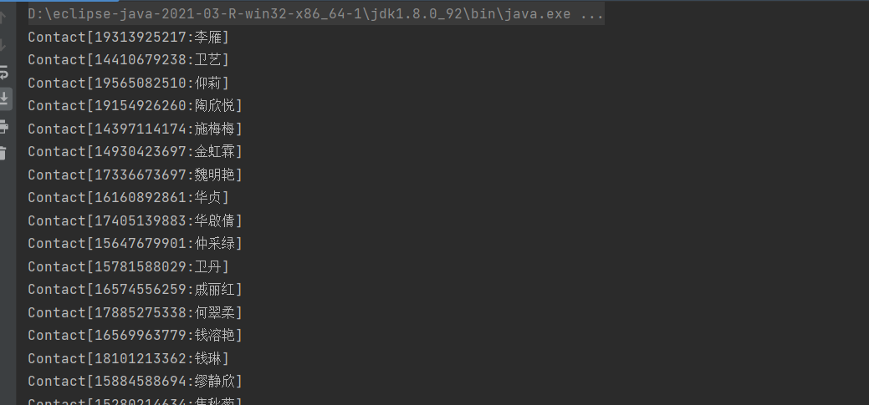

#### 1.4.3随机生成主被叫电话号码

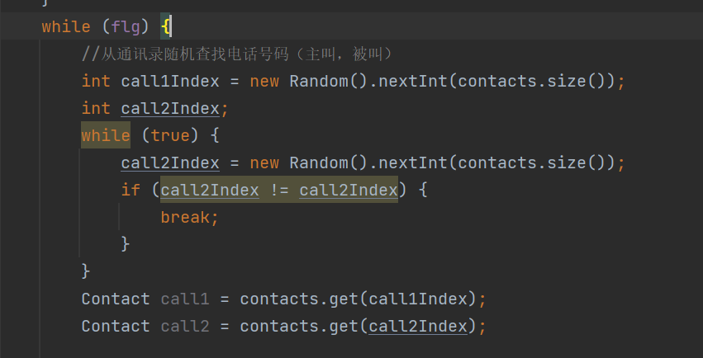

#### 1.4.4通话记录格式化类

/**  
 * @Time : 2022/12/3 15:13  
 * @Author : jin  
 * @File : NumberUtil.class  
 */  
package org.fengyue.ct_web.commom.util;  
  
import java.text.DecimalFormat;  
  
/**  
 * 数字工具类  
 */  
public class NumberUtil {  
 /**  
 * 将数字格式化为字符串  
 *  
 * @param num  
 * @param length  
 * @return  
 */  
 public static String format(int num, int length) {  
 StringBuilder stringBuilder = new StringBuilder();  
 for (int i = 1; i <= length; i++) {  
 stringBuilder.append("0");  
 }  
 DecimalFormat df = new DecimalFormat(stringBuilder.toString());  
 return df.format(num);  
 }  
}

/**  
 * @Time : 2022/12/3 15:32  
 * @Author : jin  
 * @File : DateUtil.class  
 */  
package org.fengyue.ct_web.commom.util;  
  
import Data;  
  
import java.text.ParseException;  
import java.text.SimpleDateFormat;  
import java.util.Date;  
  
public class DateUtil {  
 /**  
 * 日期对象格式化  
 *  
 * @param dateString  
 * @param format  
 * @return  
 */  
 public static Date parse(String dateString, String format) {  
 SimpleDateFormat sdf = new SimpleDateFormat(format);  
 Date date = null;  
 try {  
 date = sdf.parse(dateString);  
 } catch (ParseException e) {  
 throw new RuntimeException(e);  
 }  
 return date;  
  
 }  
  
 public static String format(Date date, String format) {  
 SimpleDateFormat sdf = new SimpleDateFormat(format);  
 return sdf.format(date);  
 }  
  
}

#### 1.4.5生成通话记录

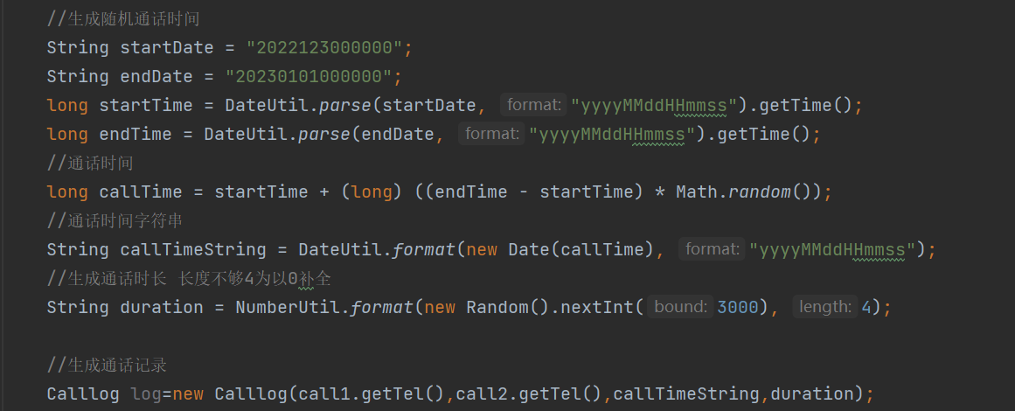

#### 1.4.6创建通话记录对象类

/**  
 * @Time : 2022/12/3 15:43  
 * @Author : jin  
 * @File : Calllog.class  
 */  
package org.fengyue.ct_web.producer.bean;  
  
public class Calllog {  
 private String call1;  
 private String call2;  
 private String calltime;  
 private String duration;  
  
 public Calllog(String call1, String call2, String calltime, String duration) {  
 this.call1 = call1;  
 this.call2 = call2;  
 this.calltime = calltime;  
 this.duration = duration;  
 }  
  
 public String getCall1() {  
 return call1;  
 }  
  
 public void setCall1(String call1) {  
 this.call1 = call1;  
 }  
  
 public String getCall2() {  
 return call2;  
 }  
  
 public void setCall2(String call2) {  
 this.call2 = call2;  
 }  
  
 public String getCalltime() {  
 return calltime;  
 }  
  
 public void setCalltime(String calltime) {  
 this.calltime = calltime;  
 }  
  
 public String getDuration() {  
 return duration;  
 }  
  
 public void setDuration(String duration) {  
 this.duration = duration;  
 }  
  
 public String toString() {  
 return call1 + "\t" + call2 + "\t" + calltime + "\t" + duration;  
 }  
}

#### 1.4.7保存通话记录

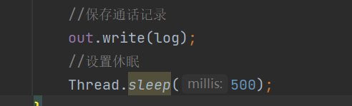

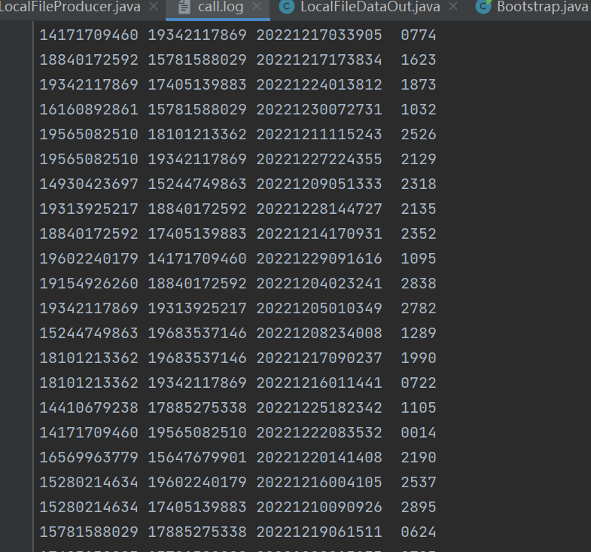

### 1.5将项目打包到服务器

#### 1.5.1修改启动类

/**  
 * @Time : 2022/12/3 12:36  
 * @Author : jin  
 * @File : Bootstrap.class  
 */  
package org.fengyue.ct_web.producer;  
  
import Producer;  
import LocalFileProducer;  
import LocalFileDataIn;  
import LocalFileDataOut;  
  
import java.io.IOException;  
  
/**  
 * 启动对象  
 */  
public class Bootstrap {  
 public static void main(String[] args) throws IOException {  
  
 if (args.length < 2) {  
 System.out.println("系统参数错误，请按照指定格式传递！");  
 System.exit(1);  
 }  
 //构建生产者对象  
 Producer producer = new LocalFileProducer();  
// producer.setIn(new LocalFileDataIn("E:\\IDEA hadoop项目\\Hadoop_CT\\Data\\In\\contact.log"));  
// producer.setOut(new LocalFileDataOut("E:\\IDEA hadoop项目\\Hadoop_CT\\Data\\Out\\call.log"));  
 producer.setIn(new LocalFileDataIn(args[0]));  
 producer.setOut(new LocalFileDataOut(args[1]));  
 //生产数据  
 producer.produce();  
 //关闭生产者对象  
 producer.close();  
 }  
}

#### 1.5.2上传测试

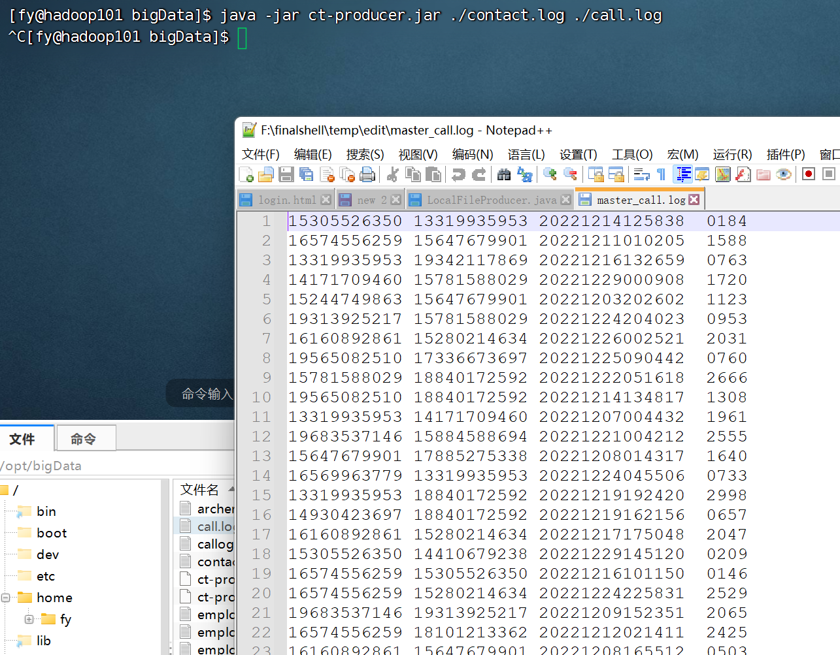

## 二.数据消费

**利用Flume和Kafka将收集不断生产的数据，并且将数据插入到HBase中**

### 2.1业务流程

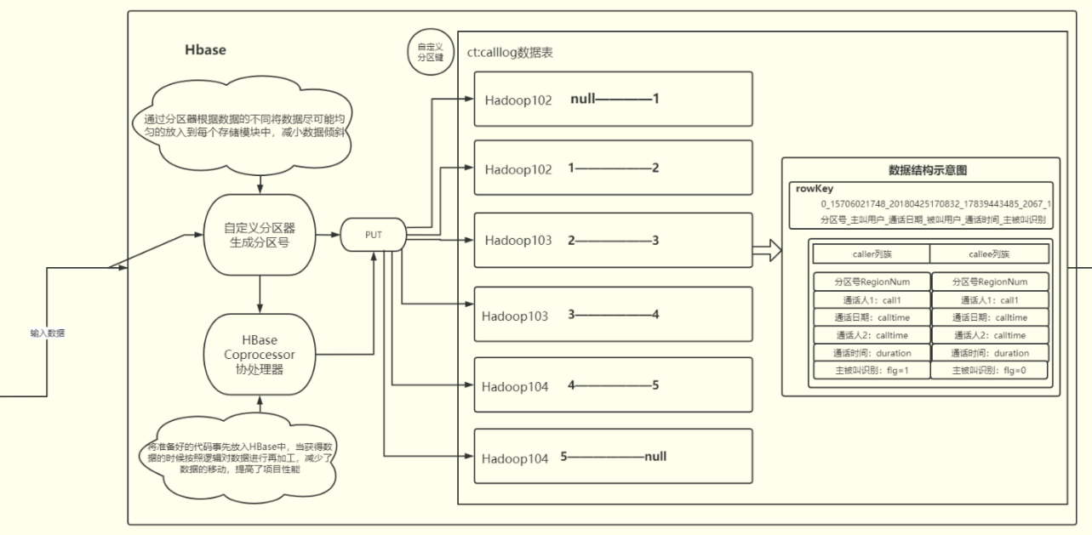

### 2.2配置Kafka

#### 2.2.1下载解压kafka

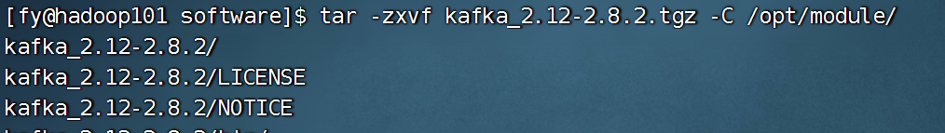

#### 2.2.2配置server.properties

1. broker.id标识本机
2. log.dirs是kafka接收消息存放路径
3. zookeeper.connect指定连接的zookeeper集群地址

#### 2.2.3分发到集群

xsync kafka212

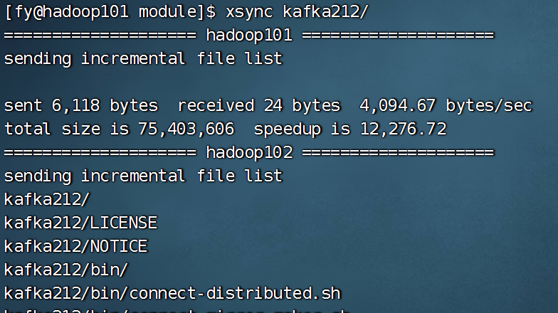

#### 2.2.4配置集群启动命令

#! /bin/bash  
case $1 in  
 "start" ){  
 for i in hadoop101 hadoop102 hadoop103;  
 do  
 echo "==============$i start=============="  
 ssh $i "/opt/module/kafka212/bin/kafka-server-start.sh -daemon /opt/module/kafka212/config/server.properties"  
 done  
};;  
 "stop" ){  
 for i in hadoop101 hadoop102 hadoop103;  
 do  
 echo "==============$i stop=============="  
 ssh $i "/opt/module/kafka212/bin/kafka-server-stop.sh"  
 done  
};;  
esac

#### 2.2.5测试

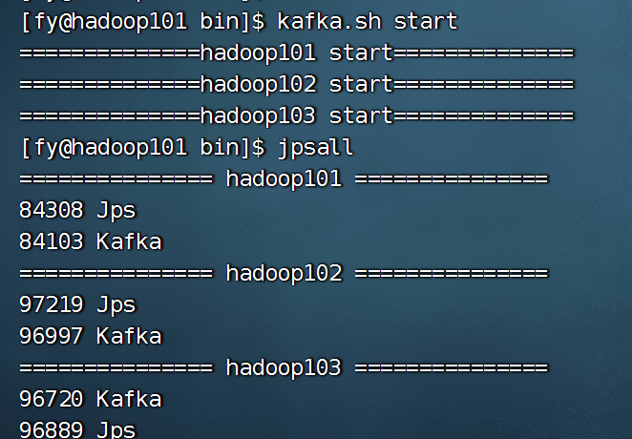

### 2.3初步使用Kafka

#### 2.3.1创建主题

kafka-topics.sh --zookeeper hadoop101:9092 --create --topic ct --partitions 3 --replication-factor 2



#### 2.3.2Kafka开始消费

kafka-console-consumer.sh --bootstrap-server hadoop101:9092 -topic ct（命令更新）

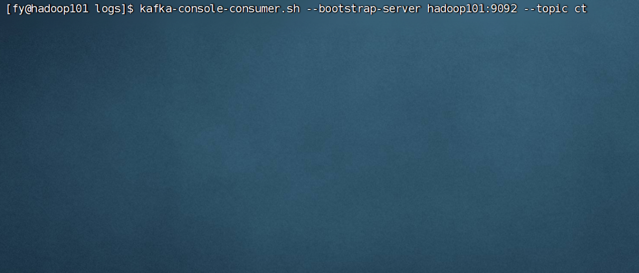

#### 2.3.3编写flume脚本

# define  
a1.sources = r1  
a1.sinks = k1  
a1.channels = c1  
  
# source  
a1.sources.r1.type = exec  
a1.sources.r1.command = tail -F -c +0 /opt/bigData/call.log  
a1.sources.r1.shell = /bin/bash -c  
  
# sink  
a1.sinks.k1.type = org.apache.flume.sink.kafka.KafkaSink  
a1.sinks.k1.kafka.bootstrap.servers = hadoop101:9092,hadoop102:9092,hadoop103:9092  
a1.sinks.k1.kafka.topic = ct  
a1.sinks.k1.kafka.flumeBatchSize = 20  
a1.sinks.k1.kafka.producer.acks = 1  
a1.sinks.k1.kafka.producer.linger.ms = 1  
  
# channel  
a1.channels.c1.type = memory  
a1.channels.c1.capacity = 1000  
a1.channels.c1.transactionCapacity = 100  
  
# bind  
a1.sources.r1.channels = c1  
a1.sinks.k1.channel = c1

#### 2.3.4启动flume脚本

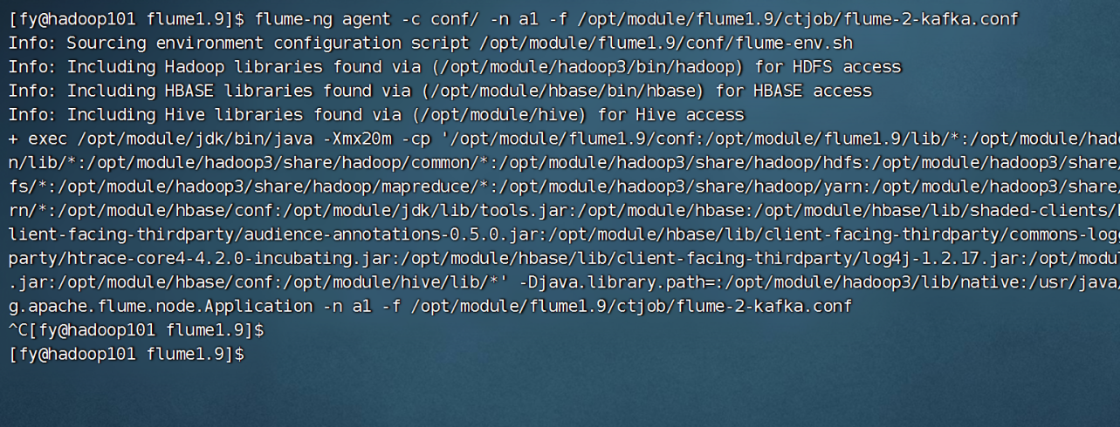

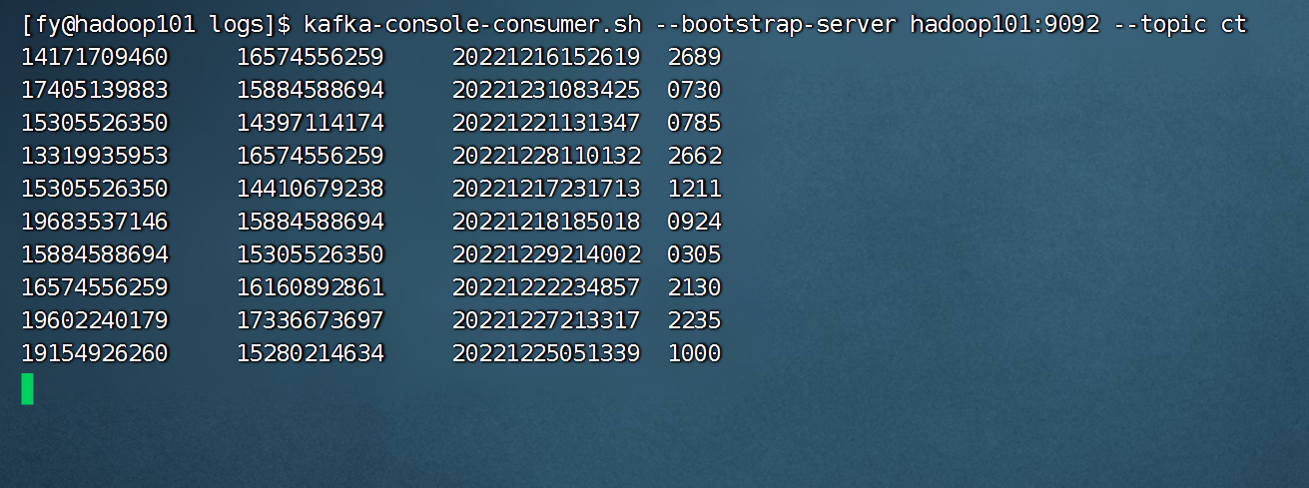

### 2.4创建Kafka JavaAPI

#### 2.4.1创建消费者对象

package org.fengyue.ct_web.commom.bean;  
  
import java.io.Closeable;  
  
/**  
 * 消费者类  
 */  
public interface Consumer extends Closeable {  
  
 /**  
 * 消费数据  
 */  
 public void consume();  
}

#### 2.4.2创建配置文件

bootstrap.servers=hadoop101:9092,hadoop102:9092,hadoop103:9092  
key.deserializer=org.apache.kafka.common.serialization.StringDeserializer  
value.deserializer=org.apache.kafka.common.serialization.StringDeserializer  
group.id=fengyue  
enable.auto.commit=true  
auto.commit.interval.ms=1000

#### 2.4.3创建消费者对象

/**  
 * @Time : 2022/12/4 0:35  
 * @Author : jin  
 * @File : CalllogConsumer.class  
 */  
package org.fengyue.ct_web.consumer.bean;  
  
import org.apache.kafka.clients.consumer.ConsumerRecord;  
import org.apache.kafka.clients.consumer.ConsumerRecords;  
import org.apache.kafka.clients.consumer.KafkaConsumer;  
import Consumer;  
import Names;  
  
import java.io.IOException;  
import java.util.Arrays;  
import java.util.Properties;  
  
/**  
 * 通话日志消费者对象  
 */  
public class CalllogConsumer implements Consumer {  
 /**  
 * 消费数据  
 */  
 @Override  
 public void consume() {  
  
 try {  
 //创建配置对象  
 Properties prop = new Properties();  
 prop.load(Thread.currentThread().getContextClassLoader().getResourceAsStream("consumer.properties"));  
 //获取flume采集的数据  
 KafkaConsumer<String, String> consumer = new KafkaConsumer<String, String>(prop);  
 //关注主题  
 consumer.subscribe(Arrays.asList(Names.TOPIC.getVal()));  
 //消费数据  
 while (true) {  
 ConsumerRecords<String, String> consumerRecords = consumer.poll(100);  
 for (ConsumerRecord<String, String> consumerRecord : consumerRecords) {  
 System.out.println(consumerRecord.value());  
 }  
 }  
  
 } catch (Exception e) {  
 e.printStackTrace();  
 }  
 }  
  
 /**  
 * 释放资源  
 *  
 * @throws IOException  
 */  
 @Override  
 public void close() throws IOException {  
  
 }  
}

#### 2.4.4创建启动类

/**  
 * @Time : 2022/12/4 0:32  
 * @Author : jin  
 * @File : Bootstarp.class  
 */  
package org.fengyue.ct_web.consumer;  
  
import Consumer;  
import CalllogConsumer;  
  
import java.io.IOException;  
  
/**  
 * 启动类  
 * 使用Kafka消费者获取Flume采集的数据  
 * 将数据存储到Hbase  
 */  
public class Bootstrap {  
 public static void main(String[] args) throws IOException {  
 //创建消费者  
 Consumer consumer = new CalllogConsumer();  
 //消费数据  
 consumer.consume();  
 //关闭资源  
 consumer.close();  
  
 }  
}

#### 2.4.5测试API

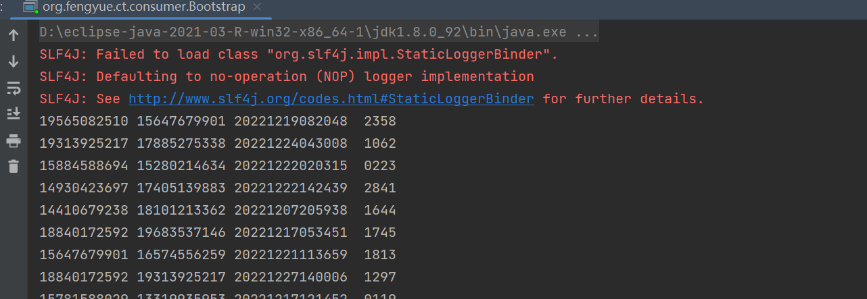

### 2.5API结合Hbase

#### 2.5.1创建dao层

/**  
 * @Time : 2022/12/4 1:05  
 * @Author : jin  
 * @File : HbaseDao.class  
 */  
package org.fengyue.ct_web.consumer.dao;  
  
import org.apache.hadoop.hbase.client.Put;  
import org.apache.hadoop.hbase.util.Bytes;  
import org.apache.hadoop.yarn.webapp.hamlet.Hamlet;  
import BaseDao;  
import Names;  
import ValueConstant;  
  
/**  
 * Hbase数据访问对象  
 */  
public class HbaseDao extends BaseDao {  
 /**  
 * 初始化  
 */  
 public void init() throws Exception {  
  
 }  
  
 /**  
 * 插入数据  
 *  
 * @param value  
 */  
 public void insertData(String value) throws Exception {  
  
 //3.保存数据  
 putData();  
 }  
}

#### 2.5.2创建基础数据访问对象

/**  
 * @Time : 2022/12/4 1:03  
 * @Author : jin  
 * @File : BaseDao.class  
 */  
package org.fengyue.ct_web.commom.bean;  
  
import org.apache.hadoop.conf.Configuration;  
import org.apache.hadoop.hbase.*;  
import org.apache.hadoop.hbase.client.*;  
import org.apache.hadoop.hbase.util.Bytes;  
import Names;  
import ValueConstant;  
  
import java.io.IOException;  
import java.util.ArrayList;  
import java.util.List;  
  
/**  
 * 基础数据访问对象  
 */  
public abstract class BaseDao {  
  
 private ThreadLocal<Connection> connHolder = new ThreadLocal<Connection>();  
 private ThreadLocal<Admin> adminHolder = new ThreadLocal<Admin>();  
  
 protected void start() throws IOException {  
 getConnection();  
 getAdmin();  
  
 }  
  
 protected void end() throws IOException {  
 Admin admin = getAdmin();  
 if (admin != null) {  
 admin.close();  
 adminHolder.remove();  
 }  
 Connection coon = getConnection();  
 if (coon != null) {  
 coon.close();  
 connHolder.remove();  
 }  
 }  
  
 /**  
 * 创建表  
 * 如果表存在则删除，删除后创建新表  
 */  
 protected void createTableXX(String name, Integer regionCount, String... families) throws Exception {  
  
 Admin admin = getAdmin();  
 TableName tableName = TableName.valueOf(name);  
  
 if (admin.tableExists(tableName)) {  
 //表存在删除表  
 deleteTable(name);  
 }  
 //创建表  
 createTable(name, regionCount, families);  
 }  
  
 protected void createTableXX(String name, String... families) throws Exception {  
  
 createTableXX(name, null, families);  
 }  
  
 /**  
 * 增加数据  
 */  
 protected void putData(String name, Put put) throws IOException {  
  
 //获取表对象  
 Connection conn = getConnection();  
 Table table = conn.getTable(TableName.valueOf(name));  
 //增加数据  
 table.put(put);  
 //关闭表  
 table.close();  
 }  
  
 /**  
 * 删除表方法  
 *  
 * @param name  
 * @throws Exception  
 */  
 protected void deleteTable(String name) throws Exception {  
 TableName tableName = TableName.valueOf(name);  
 Admin admin = getAdmin();  
 admin.disableTable(tableName);  
 admin.deleteTable(tableName);  
 }  
  
 /**  
 * 创建表  
 *  
 * @param name  
 * @param families  
 * @throws Exception  
 */  
 private void createTable(String name, Integer regionCount, String... families) throws Exception {  
  
 TableName tableName = TableName.valueOf(name);  
 Admin admin = getAdmin();  
  
 HTableDescriptor tableDescriptor = new HTableDescriptor(tableName);  
 if (families == null || families.length == 0) {  
 families = new String[1];  
 families[0] = Names.CF_INFO.getVal();  
 }  
 for (String family : families) {  
 HColumnDescriptor columnDescriptor = new HColumnDescriptor(family);  
 tableDescriptor.addFamily(columnDescriptor);  
 }  
 //增加预分区  
 //分区键  
 if (regionCount == null || regionCount <= 1) {  
 admin.createTable(tableDescriptor);  
 } else {  
 byte[][] splitKeys = genSplitKeys(regionCount);  
 admin.createTable(tableDescriptor, splitKeys);  
 }  
 }  
  
 /**  
 * 计算分区号  
 *  
 * @return  
 */  
 protected int genRegionNum(String tel, String date) {  
 String usercode = tel.substring(tel.length() - 4);  
 String yearMonth = date.substring(0, 6);  
 int userCodeHash = usercode.hashCode();  
 int yearMonthHash = yearMonth.hashCode();  
  
 //ccr检验采用异或算法  
 int ccr = Math.abs(userCodeHash ^ yearMonthHash);  
 //取模  
 int regionNum = ccr % ValueConstant.REGION_COUNT;  
  
 return regionNum;  
 }  
  
  
 /**  
 * 生成分区键  
 *  
 * @return  
 */  
 private byte[][] genSplitKeys(int regionCount) {  
  
 int splitKeyCount = regionCount - 1;  
 byte[][] bs = new byte[splitKeyCount][];  
 List<byte[]> bsList = new ArrayList<byte[]>();  
 for (int i = 0; i < splitKeyCount; i++) {  
 String splitkey = i + "|";  
 bsList.add(Bytes.toBytes(splitkey));  
 }  
 bsList.toArray(bs);  
 return bs;  
  
 }  
  
 /**  
 * 创建命名空间  
 * 如果存在不需要创建否则创建新的  
 *  
 * @param namespace  
 */  
 protected void createNamespaceNX(String namespace) throws IOException {  
 Admin admin = getAdmin();  
 try {  
 admin.getNamespaceDescriptor(namespace);  
 } catch (NamespaceNotFoundException e) {  
  
 NamespaceDescriptor namespaceDescriptor = NamespaceDescriptor.create(namespace).build();  
 admin.createNamespace(namespaceDescriptor);  
 }  
 }  
  
 /**  
 * 获取管理对象  
 *  
 * @return  
 */  
 protected synchronized Admin getAdmin() throws IOException {  
 Admin admin = adminHolder.get();  
 if (admin == null) {  
 admin = getConnection().getAdmin();  
 adminHolder.set(admin);  
 }  
 return admin;  
 }  
  
 /**  
 * 获取连接对象  
 *  
 * @return  
 */  
 protected Connection getConnection() throws IOException {  
 Connection conn = connHolder.get();  
 if (conn == null) {  
 Configuration conf = HBaseConfiguration.create();  
 conn = ConnectionFactory.createConnection(conf);  
 connHolder.set(conn);  
 }  
 return conn;  
 }  
  
}

#### 2.5.3在Hbase中创建对应的表格

public void init() throws Exception {  
 start();  
  
 createNamespaceNX(Names.NAMESPACE.getVal());  
 createTableXX(Names.TABLE.getVal(), ValueConstant.REGION_COUNT, Names.CF_CALLER.getVal());  
  
 end();  
}

#### 2.5.4设置两个列族和rowkey

public void insertData(String value) throws Exception {  
 //将通话体制保存到Hbase中  
 //1.获取通话日志数据  
 String[] values = value.split("\t");  
 String call1 = values[0];  
 String call2 = values[1];  
 String calltime = values[2];  
 String duration = values[3];  
  
 //2.创建数据对象  
 /*  
 rowkey设计  
 rowkey应该具备唯一性  
 最大值64KB 推荐长度10~100byte 最好是8的倍数  
 散列原则：盐值散列：不能使用时间戳 在rowkey前增加随机数  
 字符串反转：电话号码  
 计算分区号：hashMap  
 */  
 String rowkey = genRegionNum(call1, calltime) + "_" + call1 + "_" + calltime + "_" + call2 + "_" + duration;  
 Put put = new Put(Bytes.toBytes(rowkey));  
 byte[] family = Bytes.toBytes(Names.CF_CALLER.getVal());  
  
 put.addColumn(family, Bytes.toBytes("call1"), Bytes.toBytes(call1));  
 put.addColumn(family, Bytes.toBytes("call2"), Bytes.toBytes(call2));  
 put.addColumn(family, Bytes.toBytes("calltime"), Bytes.toBytes(calltime));  
 put.addColumn(family, Bytes.toBytes("duration"), Bytes.toBytes(duration));  
 //3.保存数据  
 putData(Names.TABLE.getVal(), put);  
}

#### 2.5.5测试

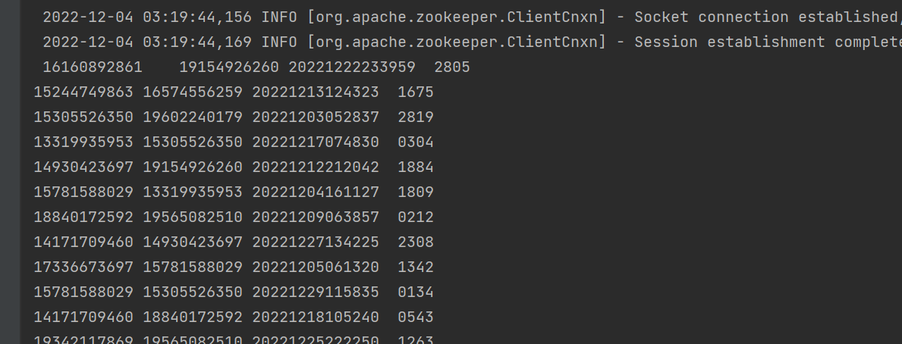

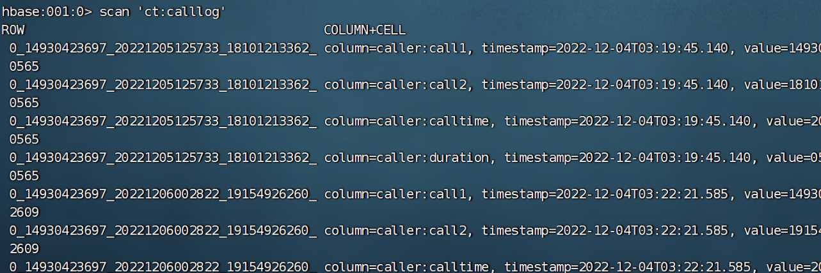

### 2.5.6封装Hbase对象

#### 2.5.6.1创建api

package org.fengyue.ct_web.commom.api;  
  
import java.lang.annotation.Retention;  
import java.lang.annotation.RetentionPolicy;  
import java.lang.annotation.Target;  
  
import static java.lang.annotation.ElementType.*;  
  
@Target({TYPE})  
@Retention(RetentionPolicy.RUNTIME)  
public @interface TableRef {  
 String value();  
}

package org.fengyue.ct_web.commom.api;  
  
import java.lang.annotation.Retention;  
import java.lang.annotation.RetentionPolicy;  
import java.lang.annotation.Target;  
  
import static java.lang.annotation.ElementType.FIELD;  
  
  
@Target({FIELD})  
@Retention(RetentionPolicy.RUNTIME)  
public @interface RowKey {  
  
}

package org.fengyue.ct_web.commom.api;  
  
import java.lang.annotation.Retention;  
import java.lang.annotation.RetentionPolicy;  
import java.lang.annotation.Target;  
  
import static java.lang.annotation.ElementType.FIELD;  
  
@Target({FIELD})  
@Retention(RetentionPolicy.RUNTIME)  
public @interface Column {  
 String family() default "info";  
  
 String column() default "";  
}

#### 2.5.6.2创建通话日志类

/**  
 * @Time : 2022/12/4 13:25  
 * @Author : jin  
 * @File : Calllog.class  
 */  
package org.fengyue.ct_web.consumer.bean;  
  
import Column;  
import RowKey;  
import TableRef;  
  
/**  
 * 通话日志  
 */  
@TableRef("ct:calllog")  
public class Calllog {  
 @RowKey  
 private String rowkey;  
 @Column(family = "caller")  
 private String call1;  
 @Column(family = "caller")  
 private String call2;  
 @Column(family = "caller")  
 private String calltime;  
 @Column(family = "caller")  
 private String duration;  
  
  
 public Calllog() {  
  
 }  
  
  
 public String getRowkey() {  
 return rowkey;  
 }  
  
 public void setRowkey(String rowkey) {  
 this.rowkey = rowkey;  
 }  
  
 public Calllog(String data) {  
 String[] values = data.split("\t");  
 call1 = values[0];  
 call2 = values[1];  
 calltime = values[2];  
 duration = values[3];  
 }  
  
 public String getCall1() {  
 return call1;  
 }  
  
 public void setCall1(String call1) {  
 this.call1 = call1;  
 }  
  
 public String getCall2() {  
 return call2;  
 }  
  
 public void setCall2(String call2) {  
 this.call2 = call2;  
 }  
  
 public String getCalltime() {  
 return calltime;  
 }  
  
 public void setCalltime(String calltime) {  
 this.calltime = calltime;  
 }  
  
 public String getDuration() {  
 return duration;  
 }  
  
 public void setDuration(String duration) {  
 this.duration = duration;  
 }  
  
  
}

#### 2.5.6.3重写添加方法

/**  
 * 增加对象自动封装对象，将数据对象直接保存在hbase中  
 *  
 * @param obj  
 */  
protected void putData(Object obj) throws Exception {  
  
 //反射  
 Class clazz = obj.getClass();  
 TableRef tableRef = (TableRef) clazz.getAnnotation(TableRef.class);  
 String tableName = tableRef.value();  
  
 Field[] fs = clazz.getDeclaredFields();  
  
  
 String stringRowKey = "";  
 for (Field f : fs) {  
 f.setAccessible(true);  
 RowKey rowKey = f.getAnnotation(RowKey.class);  
 if (rowKey != null) {  
 stringRowKey = (String) f.get(obj);  
 break;  
 }  
 }  
 //获取表对象  
 Connection conn = getConnection();  
 Table table = conn.getTable(TableName.valueOf(tableName));  
 Put put = new Put(Bytes.toBytes(stringRowKey));  
  
 for (Field f : fs) {  
 f.setAccessible(true);  
 Column column = f.getAnnotation(Column.class);  
 if (column != null) {  
 String family = column.family();  
 String colName = column.column();  
 if (colName == null || "".equals(colName)) {  
 colName = f.getName();  
 }  
 String value = (String) f.get(obj);  
 put.addColumn(Bytes.toBytes(family), Bytes.toBytes(colName), Bytes.toBytes(value));  
 }  
 }  
  
 //增加数据  
 table.put(put);  
 //关闭表  
 table.close();  
  
}

#### 2.5.6.4将数据封装为对象

/**  
 * 插入对象  
 *  
 * @param log  
 * @throws Exception  
 */  
public void insertData(Calllog log) throws Exception {  
 log.setRowkey(genRegionNum(log.getCall1(), log.getCalltime()) + "_" + log.getCall1() + "_" + log.getCalltime()  
 + "_" + log.getCall2() + "_" + log.getDuration());  
  
 putData(log);  
}

#### 2.5.6.5测试

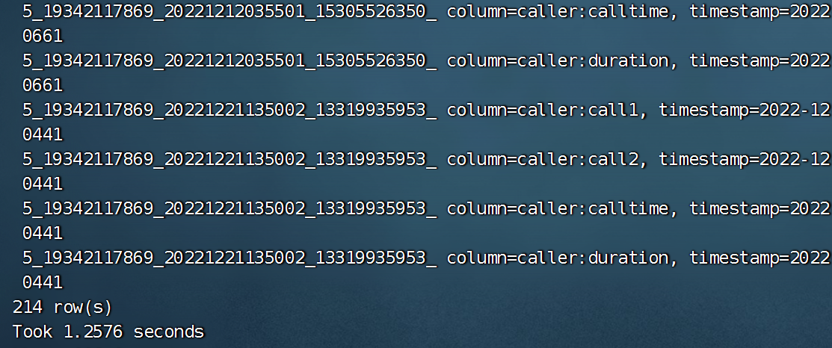

### 2.6设置过滤

#### 2.6.1获取月份区间

/**  
 * 获取查询时的startrow,stoprow集合  
 *  
 * @return  
 */  
protected static List<String[]> getStartStopRowKeys(String tel, String start, String end) {  
 List<String[]> rowkeyss = new ArrayList<String[]>();  
 String startTime = start.substring(0, 6);  
 String stopTime = end.substring(0, 6);  
  
 Calendar startCal = Calendar.getInstance();  
 startCal.setTime(DateUtil.parse(startTime, "yyyyMM"));  
  
 Calendar stopCal = Calendar.getInstance();  
 stopCal.setTime(DateUtil.parse(stopTime, "yyyyMM"));  
  
 while (startCal.getTimeInMillis() <= stopCal.getTimeInMillis()) {  
 //当前时间  
 String nowTime = DateUtil.format(startCal.getTime(), "yyyyMM");  
  
 int regionNum = genRegionNum(tel, nowTime);  
  
 String startRow = regionNum + "_" + tel + "_" + nowTime;  
 String stopRow = startRow + "|";  
 String[] rowkeys = {startRow, stopRow};  
 rowkeyss.add(rowkeys);  
  
 //月份+1  
 startCal.add(Calendar.MONTH, 1);  
 }  
 return rowkeyss;  
}

测试

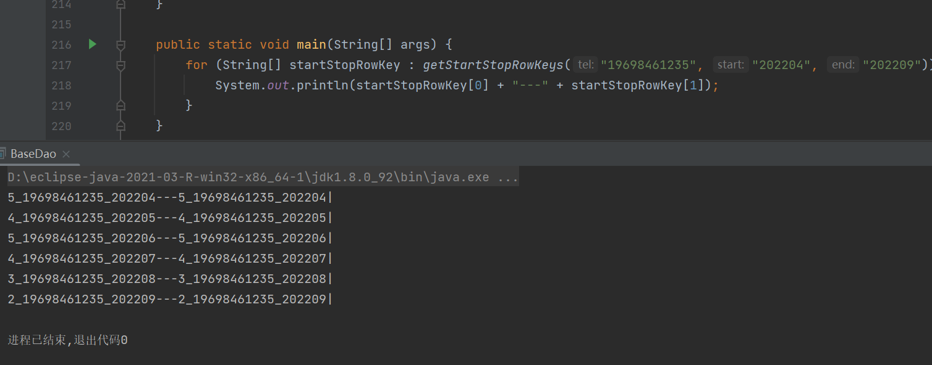

### 2.7协处理开发

#### 2.7.1区分主叫被叫

public void insertData(String value) throws Exception {  
 //将通话体制保存到Hbase中  
 //1.获取通话日志数据  
 String[] values = value.split("\t");  
 String call1 = values[0];  
 String call2 = values[1];  
 String calltime = values[2];  
 String duration = values[3];  
  
 //2.创建数据对象  
 /*  
 rowkey设计  
 rowkey应该具备唯一性  
 最大值64KB 推荐长度10~100byte 最好是8的倍数  
 散列原则：盐值散列：不能使用时间戳 在rowkey前增加随机数  
 字符串反转：电话号码  
 计算分区号：hashMap  
 */  
 //主叫用户  
 String rowkey = genRegionNum(call1, calltime) + "_" + call1 + "_" + calltime + "_" + call2 + "_" + duration + "_1";  
 Put put = new Put(Bytes.toBytes(rowkey));  
 byte[] family = Bytes.toBytes(Names.CF_CALLER.getVal());  
  
 put.addColumn(family, Bytes.toBytes("call1"), Bytes.toBytes(call1));  
 put.addColumn(family, Bytes.toBytes("call2"), Bytes.toBytes(call2));  
 put.addColumn(family, Bytes.toBytes("calltime"), Bytes.toBytes(calltime));  
 put.addColumn(family, Bytes.toBytes("duration"), Bytes.toBytes(duration));  
 put.addColumn(family, Bytes.toBytes("flg"), Bytes.toBytes("1"));  
  
 //被叫用户  
 String calleeRowkey = genRegionNum(call2, calltime) + "_" + call2 + "_" + calltime + "_" + call1 + "_" + duration + "_0";  
 Put calleePut = new Put(Bytes.toBytes(calleeRowkey));  
 byte[] calleeFamily = Bytes.toBytes(Names.CF_CALLEE.getVal());  
  
 calleePut.addColumn(calleeFamily, Bytes.toBytes("call1"), Bytes.toBytes(call2));  
 calleePut.addColumn(calleeFamily, Bytes.toBytes("call2"), Bytes.toBytes(call1));  
 calleePut.addColumn(calleeFamily, Bytes.toBytes("calltime"), Bytes.toBytes(calltime));  
 calleePut.addColumn(calleeFamily, Bytes.toBytes("duration"), Bytes.toBytes(duration));  
 calleePut.addColumn(calleeFamily, Bytes.toBytes("flg"), Bytes.toBytes("0"));  
  
 //3.保存数据  
  
 List<Put> puts = new ArrayList<Put>();  
 puts.add(put);  
 puts.add(calleePut);  
 putData(Names.TABLE.getVal(), puts);  
}

测试

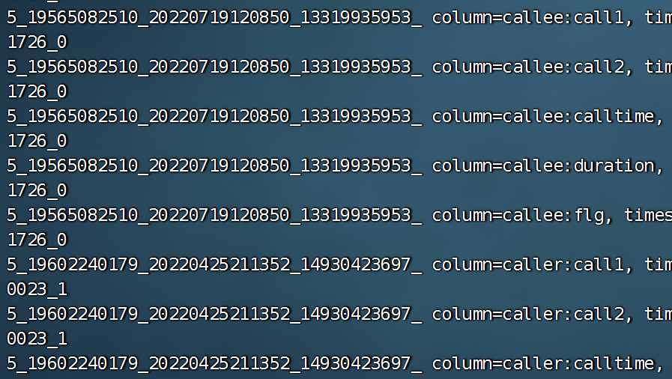

#### 2.7.2创建协处理器类

/**  
 * @Time : 2022/12/4 16:05  
 * @Author : jin  
 * @File : InsertCalleeCoprocessor.class  
 */  
package org.fengyue.ct_web.consumer.coprocessor;  
  
import org.apache.hadoop.hbase.TableName;  
import org.apache.hadoop.hbase.client.Table;  
import org.apache.hadoop.hbase.coprocessor.ObserverContext;  
import org.apache.hadoop.hbase.coprocessor.RegionCoprocessor;  
import org.apache.hadoop.hbase.coprocessor.RegionCoprocessorEnvironment;  
import org.apache.hadoop.hbase.coprocessor.RegionObserver;  
import org.apache.hadoop.hbase.util.Bytes;  
import org.apache.hadoop.hbase.wal.WALEdit;  
import org.apache.hadoop.hbase.client.Put;  
import BaseDao;  
import Names;  
  
import java.io.IOException;  
import java.util.Optional;  
  
/**  
 * 使用协处理器保存被叫用户功能  
 */  
  
public class InsertCalleeCoprocessor implements RegionObserver, RegionCoprocessor {  
 //使用RegionObserver需要重写RegionCoprocessor中的getRegionObserver方法  
 @Override  
 public Optional<RegionObserver> getRegionObserver() {  
 return Optional.of((RegionObserver) this);  
 }  
  
 /**  
 * 方法命名规则  
 * login  
 * logout  
 * prePut  
 * doPut：模板方法设计模型  
 * 存在父子类；  
 * 父类搭建算法骨架  
 * 1.tel取用户代码 2.取时间年月 3.异或算分区 4.hash散列  
 * do1.tel取后四位 do2.202212 do3. ^ do4. %  
 */  
  
 /**  
 * 保存主叫用户数据之后由Hbase自动保存被叫用户数据  
 *  
 * @param e  
 * @param put  
 * @param edit  
 * @throws IOException  
 */  
 @Override  
 public void postPut(ObserverContext<RegionCoprocessorEnvironment> e, Put put, WALEdit edit) throws IOException {  
  
 //获取表  
 Table table = e.getEnvironment().getConnection().getTable(TableName.valueOf(Names.TABLE.getVal()));  
 //主叫用户的rowkey  
 String rowkey = Bytes.toString(put.getRow());  
  
 //被叫信息  
 String[] info = rowkey.split("_");  
 String call1 = info[1];  
 String call2 = info[3];  
 String calltime = info[2];  
 String duration = info[4];  
 String flg = info[5];  
 CoprocessorDao coprocessorDao = new CoprocessorDao();  
  
 //区分主被叫  
 if ("1".equals(flg)) {  
 //只有主叫用户保存才会触发  
  
 String calleeRowkey = coprocessorDao.genRegionNum(call2, calltime) + "_" + call2 + "_" + calltime + "_" + call1 + "_" + duration + "_0";  
 Put calleePut = new Put(Bytes.toBytes(calleeRowkey));  
 byte[] calleeFamily = Bytes.toBytes(Names.CF_CALLEE.getVal());  
 calleePut.addColumn(calleeFamily, Bytes.toBytes("call1"), Bytes.toBytes(call2));  
 calleePut.addColumn(calleeFamily, Bytes.toBytes("call2"), Bytes.toBytes(call1));  
 calleePut.addColumn(calleeFamily, Bytes.toBytes("calltime"), Bytes.toBytes(calltime));  
 calleePut.addColumn(calleeFamily, Bytes.toBytes("duration"), Bytes.toBytes(duration));  
 calleePut.addColumn(calleeFamily, Bytes.toBytes("flg"), Bytes.toBytes("0"));  
 //保存  
 table.put(calleePut);  
  
 }  
 //关闭  
 table.close();  
 }  
  
 private class CoprocessorDao extends BaseDao {  
 @Override  
 public int genRegionNum(String tel, String date) {  
 return super.genRegionNum(tel, date);  
 }  
 }  
  
}

### 2.8让表知道协议处理器

#### 2.8.1 BaseDao/createTable

private void createTable(String name, String coprocessorClass, Integer regionCount, String... families) throws Exception {  
  
 TableName tableName = TableName.valueOf(name);  
 Admin admin = getAdmin();  
  
 HTableDescriptor tableDescriptor = new HTableDescriptor(tableName);  
 if (families == null || families.length == 0) {  
 families = new String[1];  
 families[0] = Names.CF_INFO.getVal();  
 }  
 for (String family : families) {  
 HColumnDescriptor columnDescriptor = new HColumnDescriptor(family);  
 tableDescriptor.addFamily(columnDescriptor);  
 }  
 //增加协议处理器  
 if (coprocessorClass != null && !"".equals(coprocessorClass)) {  
 tableDescriptor.addCoprocessor(coprocessorClass);  
 }  
  
 //增加预分区  
 if (regionCount == null || regionCount <= 1) {  
 admin.createTable(tableDescriptor);  
 } else {  
 //分区键  
 byte[][] splitKeys = genSplitKeys(regionCount);  
 admin.createTable(tableDescriptor, splitKeys);  
 }  
}

#### 2.8.2 BaseDao/createTableXX

protected void createTableXX(String name, String coprocessorClass, Integer regionCount, String... families) throws Exception {  
  
 Admin admin = getAdmin();  
 TableName tableName = TableName.valueOf(name);  
  
 if (admin.tableExists(tableName)) {  
 //表存在删除表  
 deleteTable(name);  
 }  
 //创建表  
 createTable(name, coprocessorClass, regionCount, families);  
}

#### 2.8.3 BaseDao/createTableXX

protected void createTableXX(String name, String... families) throws Exception {  
  
 createTableXX(name, null, null, families);  
}

#### 2.8.4 HbaseDao/init

public void init() throws Exception {  
 start();  
  
 createNamespaceNX(Names.NAMESPACE.getVal());  
 createTableXX(Names.TABLE.getVal(), "InsertCalleeCoprocessor",  
 ValueConstant.REGION_COUNT, Names.CF_CALLER.getVal(), Names.CF_CALLEE.getVal());  
  
 end();  
}

### 2.9打包上传测试



#### 2.9.1分发jar包

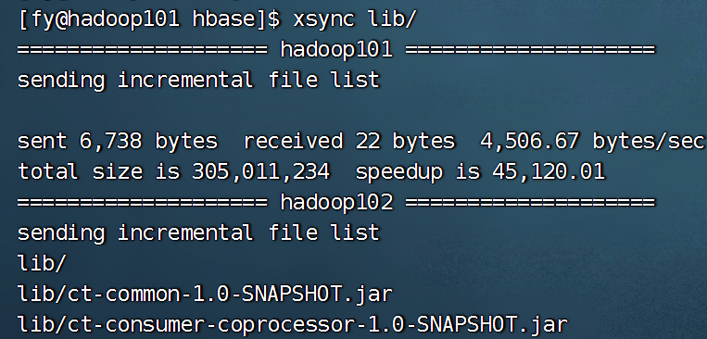

#### 2.9.2测试

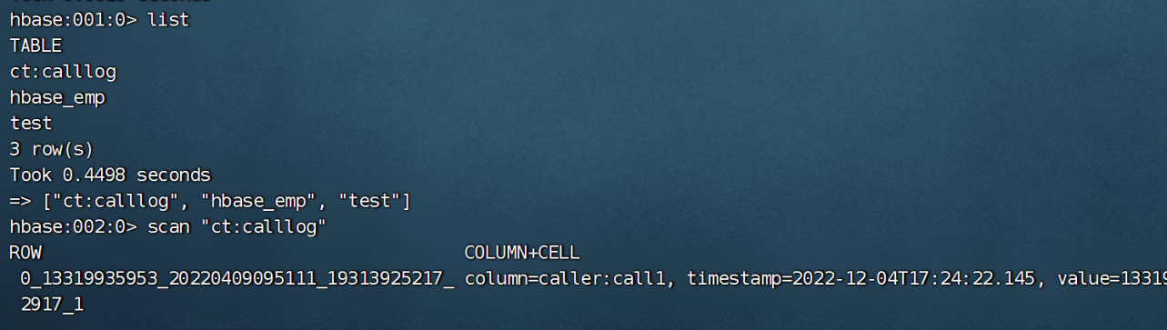

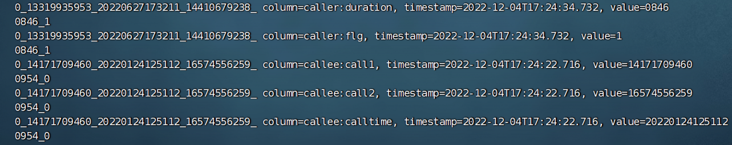

## 三.数据分析

### 3.1业务流程

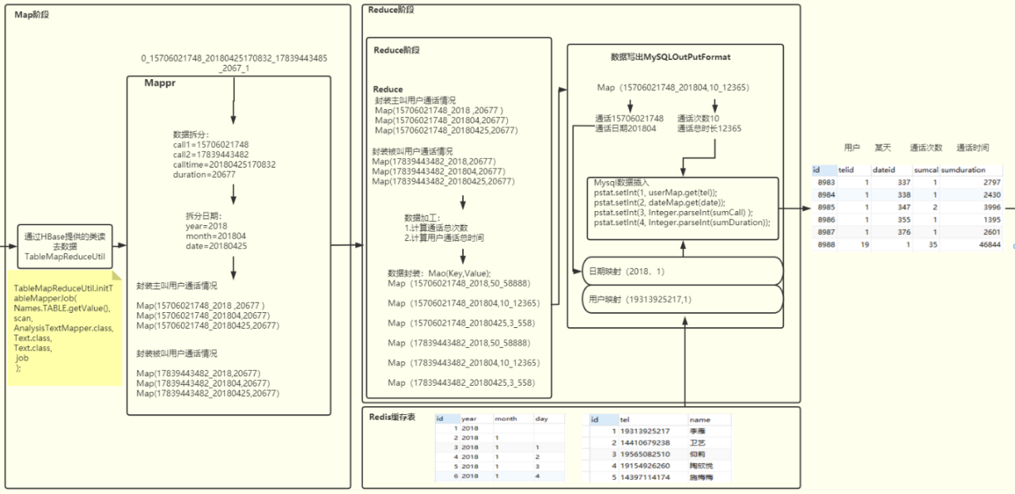

### 3.2MySQL表设计

业务指标：

a) 用户每天主叫通话个数统计，通话时间统计。

b) 用户每月通话记录统计，通话时间统计。

c) 用户之间亲密关系统计。（通话次数与通话时间体现用户亲密关系）

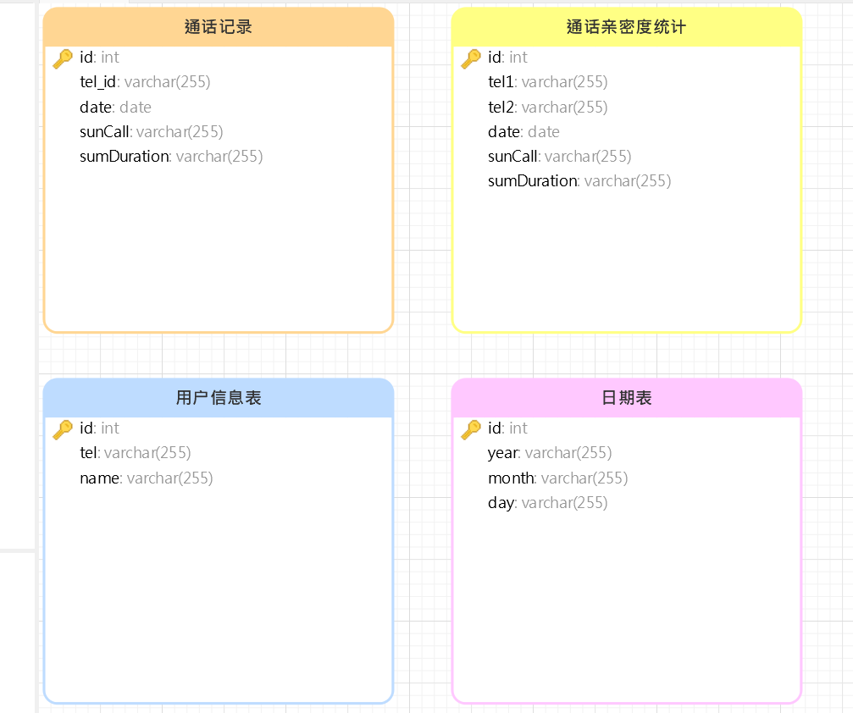

### 3.3数据计算-启动类

/**  
 * @Time : 2022/12/4 18:42  
 * @Author : jin  
 * @File : AnalysisData.class  
 */  
package org.fengyue.ct_web.analysis;  
  
import org.apache.hadoop.util.ToolRunner;  
import AnalysisTextTool;  
  
/**  
 * 分析数据  
 */  
public class AnalysisData {  
 public static void main(String[] args) throws Exception {  
 int result = ToolRunner.run(new AnalysisTextTool(), args);  
 }  
}

### 3.2数据计算-Mapper

/**  
 * @Time : 2022/12/4 19:11  
 * @Author : jin  
 * @File : AnalysisTextMapper.class  
 */  
package org.fengyue.ct_web.analysis.mapper;  
  
import org.apache.hadoop.hbase.client.Result;  
import org.apache.hadoop.hbase.io.ImmutableBytesWritable;  
import org.apache.hadoop.hbase.mapreduce.TableMapper;  
import org.apache.hadoop.hbase.util.Bytes;  
import org.apache.hadoop.io.Text;  
import org.apache.hadoop.mapreduce.Mapper;  
  
import java.io.IOException;  
  
/**  
 * 分析数据的mapper  
 */  
public class AnalysisTextMapper extends TableMapper<Text, Text> {  
 @Override  
 protected void map(ImmutableBytesWritable key, Result value, Mapper<ImmutableBytesWritable, Result, Text, Text>.Context context) throws IOException, InterruptedException {  
  
 //  
 String rowkey = Bytes.toString(key.get());  
  
 String[] info = rowkey.split("_");  
  
 String call1 = info[1];  
 String call2 = info[3];  
 String calltime = info[2];  
 String duration = info[4];  
  
 String year = calltime.substring(0, 4) + "0000";  
 String month = calltime.substring(0, 6) + "00";  
 String day = calltime.substring(0, 8);  
  
  
 //主叫用户  
 //年  
 context.write(new Text(call1 + "_" + year), new Text(duration));  
 //月  
 context.write(new Text(call1 + "_" + month), new Text(duration));  
 //日  
 context.write(new Text(call1 + "_" + day), new Text(duration));  
  
  
 //被叫用户  
 context.write(new Text(call2 + "_" + year), new Text(duration));  
 context.write(new Text(call2 + "_" + month), new Text(duration));  
 context.write(new Text(call2 + "_" + day), new Text(duration));  
 }  
}

### 3.3数据计算-Reducer

/**  
 * @Time : 2022/12/4 19:15  
 * @Author : jin  
 * @File : AnalysisTextReduce.class  
 */  
package org.fengyue.ct_web.analysis.reducer;  
  
import org.apache.hadoop.io.Text;  
import org.apache.hadoop.mapreduce.Reducer;  
  
import java.io.IOException;  
  
/**  
 * 分析数据库Reducer  
 */  
public class AnalysisTextReducer extends Reducer<Text, Text, Text, Text> {  
 @Override  
 protected void reduce(Text key, Iterable<Text> values, Context context) throws IOException, InterruptedException {  
 int sumCall = 0;  
 int sumDuration = 0;  
 for (Text value : values) {  
 sumCall++;  
 sumDuration += Integer.parseInt(value.toString());  
 }  
 context.write(key, new Text(sumCall + "_" + sumDuration));  
 }  
  
}

### 3.4数据计算-OutPutFormat

/**  
 * @Time : 2022/12/4 19:19  
 * @Author : jin  
 * @File : MySQLTextOutPutFormat.class  
 */  
package org.fengyue.ct_web.analysis.io;  
  
import org.apache.hadoop.io.Text;  
import org.apache.hadoop.mapreduce.*;  
import org.apache.hadoop.mapreduce.lib.output.FileOutputFormat;  
  
import java.io.IOException;  
import java.sql.PreparedStatement;  
import java.sql.SQLException;  
  
import org.apache.hadoop.fs.Path;  
import org.apache.hadoop.mapreduce.lib.output.FileOutputCommitter;  
import JDBCUtil;  
  
import java.sql.Connection;  
  
  
/**  
 * MySQL数据格式化输出对象  
 */  
public class MySQLOutPutFormat extends OutputFormat<Text, Text> {  
 protected static class MySQLRecordWriter extends RecordWriter<Text, Text> {  
 private Connection connection = null;  
  
 public MySQLRecordWriter() {  
 //获取资源  
 connection = JDBCUtil.getConnection();  
 }  
  
 /**  
 * 输出数据  
 *  
 * @param key  
 * @param value  
 * @throws IOException  
 * @throws InterruptedException  
 */  
 @Override  
 public void write(Text key, Text value) throws IOException, InterruptedException {  
 String[] info = value.toString().split("_");  
 int sumCall = Integer.parseInt(info[0]);  
 int sumDuration = Integer.parseInt(info[1]);  
  
 PreparedStatement pstat = null;  
 try {  
  
 String insertSQL = "insert into calllog (tel_id,date,sumcall,sumduration) values (?, ?, ? ,?)";  
 pstat = connection.prepareStatement(insertSQL);  
  
 pstat.setInt(1, 2);  
 pstat.setInt(2, 3);  
 pstat.setInt(3, sumCall);  
 pstat.setInt(4, sumDuration);  
  
 pstat.executeUpdate();  
  
 } catch (Exception e) {  
 e.printStackTrace();  
 } finally {  
 if (pstat != null) {  
 try {  
 pstat.close();  
 } catch (SQLException e) {  
 e.printStackTrace();  
 }  
 }  
 }  
 }  
  
 /**  
 * 释放资源  
 *  
 * @param taskAttemptContext  
 * @throws IOException  
 * @throws InterruptedException  
 */  
 @Override  
 public void close(TaskAttemptContext taskAttemptContext) throws IOException, InterruptedException {  
 if (connection != null) {  
 try {  
 connection.close();  
 } catch (SQLException throwables) {  
 throwables.printStackTrace();  
 }  
 }  
 }  
 }  
  
  
 @Override  
 public RecordWriter<Text, Text> getRecordWriter(TaskAttemptContext taskAttemptContext) throws IOException, InterruptedException {  
 return new MySQLRecordWriter();  
 }  
  
 @Override  
 public void checkOutputSpecs(JobContext jobContext) throws IOException, InterruptedException {  
  
 }  
  
  
 public static Path getOutputPath(JobContext job) {  
 String name = job.getConfiguration().get(FileOutputFormat.OUTDIR);  
 return name == null ? null : new Path(name);  
 }  
  
 private FileOutputCommitter committer = null;  
  
 @Override  
 public OutputCommitter getOutputCommitter(TaskAttemptContext taskAttemptContext) throws IOException, InterruptedException {  
 if (committer == null) {  
 Path output = getOutputPath(taskAttemptContext);  
 committer = new FileOutputCommitter(output, taskAttemptContext);  
 }  
 return committer;  
 }  
}

### 3.5数据计算-工具类

/**  
 * @Time : 2022/12/4 18:44  
 * @Author : jin  
 * @File : AnalysisTextTool.class  
 */  
package org.fengyue.ct_web.analysis.tool;  
  
import org.apache.hadoop.conf.Configuration;  
import org.apache.hadoop.hbase.client.Scan;  
import org.apache.hadoop.hbase.util.Bytes;  
import org.apache.hadoop.io.Text;  
import org.apache.hadoop.mapreduce.Job;  
import org.apache.hadoop.mapreduce.JobStatus;  
import org.apache.hadoop.util.Tool;  
import org.apache.hadoop.hbase.mapreduce.TableMapReduceUtil;  
import MySQLTextOutPutFormat;  
import AnalysisTextMapper;  
import AnalysisTextReducer;  
import Names;  
  
  
/**  
 * 分析数据工具类  
 */  
public class AnalysisTextTool implements Tool {  
  
 @Override  
 public int run(String[] strings) throws Exception {  
 //job  
 Job job = Job.getInstance();  
 //jar包  
 job.setJarByClass(AnalysisTextTool.class);  
 //扫描  
 Scan scan = new Scan();  
 scan.addFamily(Bytes.toBytes(Names.CF_CALLER.getVal()));  
 //mapper  
 TableMapReduceUtil.initTableMapperJob(  
 Names.TABLE.getVal(),  
 scan,  
 AnalysisTextMapper.class,  
 Text.class,  
 Text.class,  
 job  
 );  
 //reducer  
 job.setReducerClass(AnalysisTextReducer.class);  
 job.setOutputKeyClass(Text.class);  
 job.setOutputValueClass(Text.class);  
 //outPutFormat  
 job.setOutputFormatClass(MySQLTextOutPutFormat.class);  
  
 boolean flg = job.waitForCompletion(true);  
 if (flg) {  
 return JobStatus.State.SUCCEEDED.getValue();  
 } else {  
 return JobStatus.State.FAILED.getValue();  
 }  
  
 }  
  
 @Override  
 public void setConf(Configuration configuration) {  
  
 }  
  
 @Override  
 public Configuration getConf() {  
 return null;  
 }  
}

### 3.6初步打包测试

**注意！避免版本冲突需要将打包好文件中的Hdfs Jar包删除并将MySQL jar包上传到hadoop依赖文件夹中！！！**

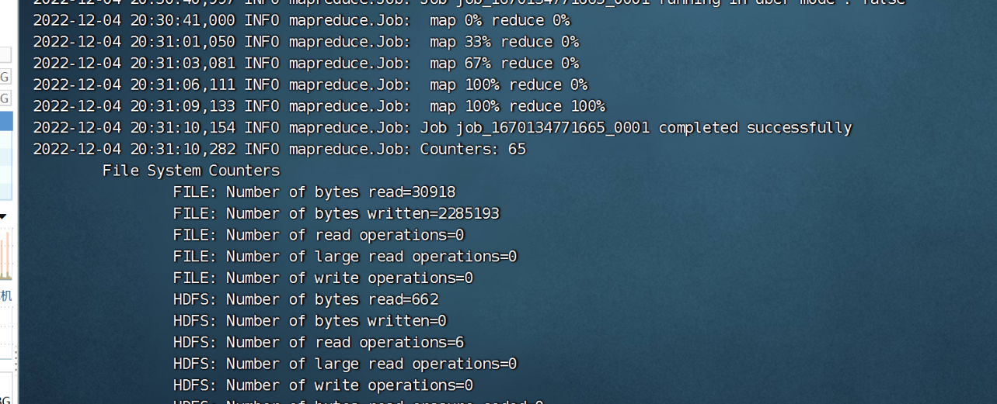

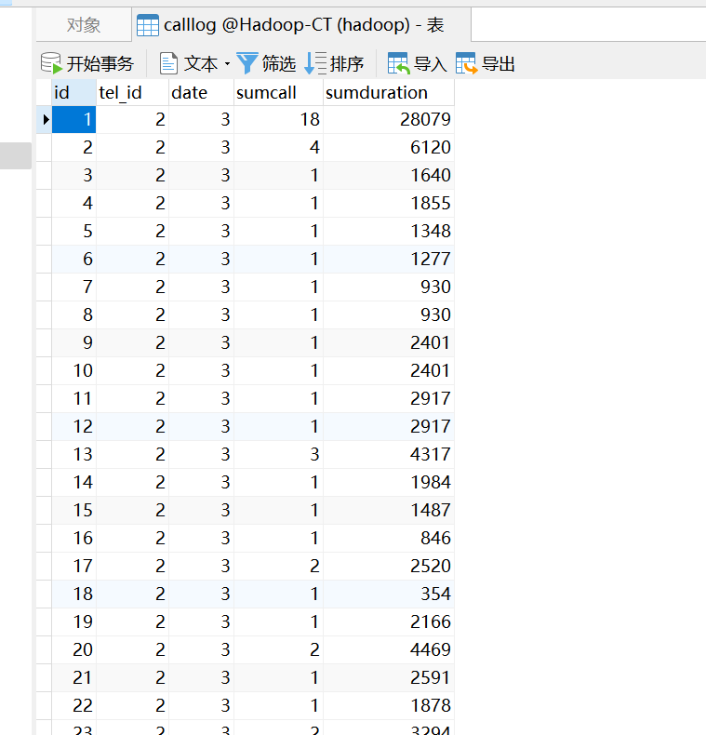

### 3.7在OutPutFormat中获取用户和时间数据

/**  
 * @Time : 2022/12/4 19:19  
 * @Author : jin  
 * @File : MySQLTextOutPutFormat.class  
 */  
package org.fengyue.ct_web.analysis.io;  
  
import org.apache.hadoop.io.Text;  
import org.apache.hadoop.mapreduce.*;  
import org.apache.hadoop.mapreduce.lib.output.FileOutputFormat;  
  
import java.io.IOException;  
import java.sql.PreparedStatement;  
import java.sql.ResultSet;  
import java.sql.SQLException;  
  
import org.apache.hadoop.fs.Path;  
import org.apache.hadoop.mapreduce.lib.output.FileOutputCommitter;  
import JDBCUtil;  
  
import java.sql.Connection;  
import java.util.HashMap;  
import java.util.Map;  
  
/**  
 * Mysql的数据格式化输出对象  
 */  
public class MySQLTextOutPutFormat extends OutputFormat<Text, Text> {  
  
 protected static class MySQLRecordWriter extends RecordWriter<Text, Text> {  
  
 private Connection connection = null;  
 Map<String, Integer> userMap = new HashMap<String, Integer>();  
 Map<String, Integer> dateMap = new HashMap<String, Integer>();  
  
 public MySQLRecordWriter() {  
 // 获取资源  
 connection = JDBCUtil.getConnection();  
 PreparedStatement pstat = null;  
 ResultSet rs = null;  
  
 try {  
  
 String queryUserSql = "select id, tel from ct_user";  
 pstat = connection.prepareStatement(queryUserSql);  
 rs = pstat.executeQuery();  
 while (rs.next()) {  
 Integer id = rs.getInt(1);  
 String tel = rs.getString(2);  
 userMap.put(tel, id);  
 }  
  
 rs.close();  
  
 String queryDateSql = "select id, year, month, day from ct_date";  
 pstat = connection.prepareStatement(queryDateSql);  
 rs = pstat.executeQuery();  
 while (rs.next()) {  
 Integer id = rs.getInt(1);  
 String year = rs.getString(2);  
 String month = rs.getString(3);  
 if (month.length() == 1) {  
 month = "0" + month;  
 }  
 String day = rs.getString(4);  
 if (day.length() == 1) {  
 day = "0" + day;  
 }  
 dateMap.put(year + month + day, id);  
 }  
  
 } catch (Exception e) {  
 e.printStackTrace();  
 } finally {  
 if (rs != null) {  
 try {  
 rs.close();  
 } catch (SQLException e) {  
 e.printStackTrace();  
 }  
 }  
 if (pstat != null) {  
 try {  
 pstat.close();  
 } catch (SQLException e) {  
 e.printStackTrace();  
 }  
 }  
 }  
 }  
  
 /**  
 * 输出数据  
 *  
 * @param key  
 * @param value  
 * @throws IOException  
 * @throws InterruptedException  
 */  
 public void write(Text key, Text value) throws IOException, InterruptedException {  
  
 String[] values = value.toString().split("_");  
 int sumCall = Integer.parseInt(values[0]);  
 int sumDuration = Integer.parseInt(values[1]);  
  
 String[] ks = key.toString().split("_");  
  
 String tel = ks[0];  
 String date = ks[1];  
  
  
 int tel_id = userMap.get(tel);  
 int date_id = dateMap.get(date);  
  
 PreparedStatement pstat = null;  
 try {  
 String insertSQL = "insert into calllog ( tel_id, date_id, sumcall, sumduration ) values ( ?, ?, ?, ? )";  
 pstat = connection.prepareStatement(insertSQL);  
  
  
 pstat.setInt(1, tel_id);  
 pstat.setInt(2, date_id);  
 pstat.setInt(3, sumCall);  
 pstat.setInt(4, sumDuration);  
 pstat.executeUpdate();  
 } catch (SQLException e) {  
 e.printStackTrace();  
 } finally {  
 if (pstat != null) {  
 try {  
 pstat.close();  
 } catch (SQLException e) {  
 e.printStackTrace();  
 }  
 }  
 }  
 }  
  
 /**  
 * 释放资源  
 *  
 * @param context  
 * @throws IOException  
 * @throws InterruptedException  
 */  
 public void close(TaskAttemptContext context) throws IOException, InterruptedException {  
 if (connection != null) {  
 try {  
 connection.close();  
 } catch (SQLException e) {  
 e.printStackTrace();  
 }  
 }  
 }  
 }  
  
 public RecordWriter<Text, Text> getRecordWriter(TaskAttemptContext context) throws IOException, InterruptedException {  
 return new MySQLRecordWriter();  
 }  
  
 public void checkOutputSpecs(JobContext context) throws IOException, InterruptedException {  
  
 }  
  
 private FileOutputCommitter committer = null;  
  
 public static Path getOutputPath(JobContext job) {  
 String name = job.getConfiguration().get(FileOutputFormat.OUTDIR);  
 return name == null ? null : new Path(name);  
 }  
  
 public OutputCommitter getOutputCommitter(TaskAttemptContext context) throws IOException, InterruptedException {  
 if (committer == null) {  
 Path output = getOutputPath(context);  
 committer = new FileOutputCommitter(output, context);  
 }  
 return committer;  
 }  
}

### 3.10安装Redis

#### 解压

sudo tar -zxvf redis-5.0.6.tar.gz -C /opt/module/

#### 安装gcc

sudo yum install gcc

#### 安装Redis

执行 make

进入root用户 执行 make install

查看安装目录 cd /usr/local/bin/

#### 配置

在根目录创建文件夹 mkdir myredis

将redis.conf移动到myredis cp redis.conf /myredis/

在myredis目录中编辑文件 vim redis.conf

设置 daemonize 为 yes

设置 logfile 目录(在redis-server同级目录下新建redis_log.log)

#### 配置环境变量

#Redis  
export REDIS_HOME=/opt/module/redis-5.0.6  
export PATH=$PATH:$REDIS_HOME/src

#### 启动

redis-server /myredis/redis.conf

#### 查看客户端

redis-cli -p 6379

### 3.11使用Redis保存缓存数据

#### 3.11.1设置redis缓存

/**  
 * @Time : 2022/12/5 14:00  
 * @Author : jin  
 * @File : Bootstrap.class  
 */  
package org.fengyue.ct_web.cache;  
  
import JDBCUtil;  
import redis.clients.jedis.Jedis;  
  
import java.sql.Connection;  
import java.sql.PreparedStatement;  
import java.sql.ResultSet;  
import java.util.HashMap;  
import java.util.Iterator;  
import java.util.Map;  
  
/**  
 * 启动缓存客户端，向redis中增加缓存数据  
 */  
public class Bootstrap {  
 public static void main(String[] args) {  
  
  
 //读取mysql数据  
 Map<String, Integer> userMap = new HashMap<String, Integer>();  
 Map<String, Integer> dateMap = new HashMap<String, Integer>();  
  
 //读取用户和时间数据  
 Connection connection = null;  
 PreparedStatement preparedStatement = null;  
 ResultSet resultSet = null;  
  
 try {  
 connection = JDBCUtil.getConnection();  
  
 String queryUserSql = "select id,tel from contacts";  
 preparedStatement = connection.prepareStatement(queryUserSql);  
 resultSet = preparedStatement.executeQuery();  
 while (resultSet.next()) {  
 Integer id = resultSet.getInt(1);  
 String tel = resultSet.getString(2);  
 userMap.put(tel, id);  
 }  
 resultSet.close();  
 //时间数据  
 String queryDateSql = "select * from calldate";  
 preparedStatement = connection.prepareStatement(queryDateSql);  
 resultSet = preparedStatement.executeQuery();  
 while (resultSet.next()) {  
 Integer id = resultSet.getInt(1);  
 String year = resultSet.getString(2);  
 String month = resultSet.getString(3);  
 //判断月份补0  
 if (month.length() == 1) {  
 month = "0" + month;  
 }  
 String day = resultSet.getString(4);  
 if (day.length() == 1) {  
 day = "0" + day;  
 }  
 dateMap.put(year + month + day, id);  
 }  
  
 } catch (Exception e) {  
 e.printStackTrace();  
 } finally {  
 if (resultSet != null) {  
 try {  
 resultSet.close();  
 } catch (Exception e) {  
 e.printStackTrace();  
 }  
 }  
 if (preparedStatement != null) {  
 try {  
 preparedStatement.close();  
 } catch (Exception e) {  
 e.printStackTrace();  
 }  
 }  
 if (connection != null) {  
 try {  
 connection.close();  
 } catch (Exception e) {  
 e.printStackTrace();  
 }  
 }  
 }  
// System.out.println(userMap.size());  
// System.out.println(dateMap.size());  
  
 //向redis存储  
 Jedis jedis = new Jedis("hadoop101", 6379);  
  
 Iterator<String> keyIterator = userMap.keySet().iterator();  
 while (keyIterator.hasNext()) {  
 String key = keyIterator.next();  
 Integer value = userMap.get(key);  
 jedis.hset("contacts", key, "" + value);  
 }  
  
 keyIterator = dateMap.keySet().iterator();  
 while (keyIterator.hasNext()) {  
 String key = keyIterator.next();  
 Integer value = dateMap.get(key);  
 jedis.hset("calldate", key, "" + value);  
 }  
  
 }  
}

#### 3.11.2修改OPF

/**  
 * @Time : 2022/12/4 19:19  
 * @Author : jin  
 * @File : MySQLRedisTextOutPutFormat.class  
 */  
package org.fengyue.ct_web.analysis.io;  
  
import org.apache.hadoop.io.Text;  
import org.apache.hadoop.mapreduce.*;  
import org.apache.hadoop.mapreduce.lib.output.FileOutputFormat;  
  
import java.io.IOException;  
import java.sql.PreparedStatement;  
import java.sql.SQLException;  
  
import org.apache.hadoop.fs.Path;  
import org.apache.hadoop.mapreduce.lib.output.FileOutputCommitter;  
import JDBCUtil;  
import redis.clients.jedis.Jedis;  
  
import java.sql.Connection;  
  
  
/**  
 * MySQL数据格式化输出对象  
 */  
public class MySQLRedisTextOutPutFormat extends OutputFormat<Text, Text> {  
  
 protected static class MySQLRecordWriter extends RecordWriter<Text, Text> {  
  
 private Connection connection = null;  
 private Jedis jedis = null;  
  
 public MySQLRecordWriter() {  
 // 获取资源  
 connection = JDBCUtil.getConnection();  
 jedis = new Jedis("hadoop101", 6379);  
 }  
  
 /**  
 * 输出数据  
 *  
 * @param key  
 * @param value  
 * @throws IOException  
 * @throws InterruptedException  
 */  
 public void write(Text key, Text value) throws IOException, InterruptedException {  
  
 String[] values = value.toString().split("_");  
 int sumCall = Integer.parseInt(values[0]);  
 int sumDuration = Integer.parseInt(values[1]);  
  
 String[] ks = key.toString().split("_");  
  
 String tel = jedis.hget("contacts", ks[0]);  
 String date = jedis.hget("calldate", ks[1]);  
  
 int tel_id = -1, date_id = -1;  
 if (null != tel) tel_id = Integer.parseInt(tel);  
 if (null != date) date_id = Integer.parseInt(date);  
  
 PreparedStatement pstat = null;  
 try {  
 if (tel_id != -1 && date_id != -1) {  
 String insertSQL = "insert into calllog ( tel_id, date_id, sumcall, sumduration ) values ( ?, ?, ?, ? )";  
 pstat = connection.prepareStatement(insertSQL);  
  
  
 pstat.setInt(1, tel_id);  
 pstat.setInt(2, date_id);  
 pstat.setInt(3, sumCall);  
 pstat.setInt(4, sumDuration);  
 pstat.executeUpdate();  
 }  
 } catch (SQLException e) {  
 e.printStackTrace();  
 } finally {  
 if (pstat != null) {  
 try {  
 pstat.close();  
 } catch (SQLException e) {  
 e.printStackTrace();  
 }  
 }  
 }  
 }  
  
 /**  
 * 释放资源  
 *  
 * @param context  
 * @throws IOException  
 * @throws InterruptedException  
 */  
 public void close(TaskAttemptContext context) throws IOException, InterruptedException {  
 if (connection != null) {  
 try {  
 connection.close();  
 } catch (SQLException e) {  
 e.printStackTrace();  
 }  
 }  
  
 if (jedis != null) {  
 jedis.close();  
 }  
 }  
 }  
  
 public RecordWriter<Text, Text> getRecordWriter(TaskAttemptContext context) throws IOException, InterruptedException {  
 return new MySQLRecordWriter();  
 }  
  
 public void checkOutputSpecs(JobContext context) throws IOException, InterruptedException {  
  
 }  
  
 private FileOutputCommitter committer = null;  
  
 public static Path getOutputPath(JobContext job) {  
 String name = job.getConfiguration().get(FileOutputFormat.OUTDIR);  
 return name == null ? null : new Path(name);  
 }  
  
 public OutputCommitter getOutputCommitter(TaskAttemptContext context) throws IOException, InterruptedException {  
 if (committer == null) {  
 Path output = getOutputPath(context);  
 committer = new FileOutputCommitter(output, context);  
 }  
 return committer;  
 }  
}

#### 3.11.3打包测试

**注意：需要先将redis jar包上传到hadoop依赖文件夹中**

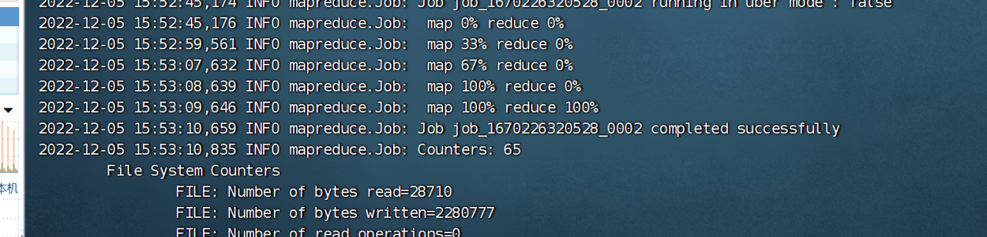

### **3.12自定义K V**

#### K V

/**  
 * @Time : 2022/12/5 15:57  
 * @Author : jin  
 * @File : AnalysisKey.class  
 */  
package org.fengyue.ct_web.analysis.kv;  
  
import org.apache.hadoop.io.WritableComparable;  
  
import java.io.DataInput;  
import java.io.DataOutput;  
import java.io.IOException;  
  
/**  
 * 自定义分析数据Key  
 */  
public class AnalysisKey implements WritableComparable<AnalysisKey> {  
 private String tel;  
 private String date;  
  
 public AnalysisKey() {  
 }  
  
 public AnalysisKey(String tel, String date) {  
 this.date = date;  
 this.tel = tel;  
 }  
  
 /**  
 * 比较 ：tel date  
 * @param key  
 * @return  
 */  
 @Override  
 public int compareTo(AnalysisKey key) {  
 int result = tel.compareTo(key.getTel());  
 if (result == 0) {  
 result = date.compareTo(key.getDate());  
 }  
 return result;  
 }  
  
 /**  
 * 读数据  
 * @param out  
 * @throws IOException  
 */  
 @Override  
 public void write(DataOutput out) throws IOException {  
 out.writeUTF(tel);  
 out.writeUTF(date);  
 }  
  
 /**  
 * 写数据  
 *  
 * @param in  
 * @throws IOException  
 */  
 @Override  
 public void readFields(DataInput in) throws IOException {  
 tel = in.readUTF();  
 date = in.readUTF();  
 }  
  
 public String getTel() {  
 return tel;  
 }  
  
 public void setTel(String tel) {  
 this.tel = tel;  
 }  
  
 public String getDate() {  
 return date;  
 }  
  
 public void setDate(String date) {  
 this.date = date;  
 }  
}

/**  
 * @Time : 2022/12/5 15:58  
 * @Author : jin  
 * @File : AnalysisValue.class  
 */  
package org.fengyue.ct_web.analysis.kv;  
  
import org.apache.hadoop.io.Writable;  
  
import java.io.DataInput;  
import java.io.DataOutput;  
import java.io.IOException;  
  
/**  
 * 自定义分析数据Value  
 */  
public class AnalysisValue implements Writable {  
 private String sumCall;  
 private String sumDuration;  
  
 public AnalysisValue() {  
 }  
  
 public AnalysisValue(String sumCall, String sumDuration) {  
 this.sumCall = sumCall;  
 this.sumDuration = sumDuration;  
 }  
  
 @Override  
 public void write(DataOutput out) throws IOException {  
 out.writeUTF(sumCall);  
 out.writeUTF(sumDuration);  
 }  
  
 @Override  
 public void readFields(DataInput in) throws IOException {  
 sumCall = in.readUTF();  
 sumDuration = in.readUTF();  
 }  
  
 public String getSumCall() {  
 return sumCall;  
 }  
  
 public void setSumCall(String sumCall) {  
 this.sumCall = sumCall;  
 }  
  
 public String getSumDuration() {  
 return sumDuration;  
 }  
  
 public void setSumDuration(String sumDuration) {  
 this.sumDuration = sumDuration;  
 }  
}

#### Mapper

/**  
 * @Time : 2022/12/4 19:11  
 * @Author : jin  
 * @File : AnalysisTextMapper.class  
 */  
package org.fengyue.ct_web.analysis.mapper;  
  
import org.apache.hadoop.hbase.client.Result;  
import org.apache.hadoop.hbase.io.ImmutableBytesWritable;  
import org.apache.hadoop.hbase.mapreduce.TableMapper;  
import org.apache.hadoop.hbase.util.Bytes;  
import org.apache.hadoop.io.Text;  
import org.apache.hadoop.mapreduce.Mapper;  
import AnalysisKey;  
  
import java.io.IOException;  
  
/**  
 * 分析数据的mapper  
 */  
public class AnalysisBeanMapper extends TableMapper<AnalysisKey, Text> {  
  
 @Override  
 protected void map(ImmutableBytesWritable key, Result value, Context context) throws IOException, InterruptedException {  
  
 //  
 String rowkey = Bytes.toString(key.get());  
  
 String[] info = rowkey.split("_");  
  
 String call1 = info[1];  
 String call2 = info[3];  
 String calltime = info[2];  
 String duration = info[4];  
  
 String year = calltime.substring(0, 4);  
 String month = calltime.substring(0, 6);  
 String day = calltime.substring(0, 8);  
  
  
 //主叫用户  
 //年  
 context.write(new AnalysisKey(call1, year), new Text(duration));  
 //月  
 context.write(new AnalysisKey(call1, month), new Text(duration));  
 //日  
 context.write(new AnalysisKey(call1, day), new Text(duration));  
  
  
 //被叫用户  
 context.write(new AnalysisKey(call2, year), new Text(duration));  
 context.write(new AnalysisKey(call2, month), new Text(duration));  
 context.write(new AnalysisKey(call2, day), new Text(duration));  
 }  
}

#### Reducer

/**  
 * @Time : 2022/12/4 19:15  
 * @Author : jin  
 * @File : AnalysisTextReduce.class  
 */  
package org.fengyue.ct_web.analysis.reducer;  
  
import org.apache.hadoop.io.Text;  
import org.apache.hadoop.mapreduce.Reducer;  
import AnalysisKey;  
import AnalysisValue;  
  
import java.io.IOException;  
  
/**  
 * 分析数据库Reducer  
 */  
public class AnalysisBeanReducer extends Reducer<AnalysisKey, Text, AnalysisKey, AnalysisValue> {  
 @Override  
 protected void reduce(AnalysisKey key, Iterable<Text> values, Context context) throws IOException, InterruptedException {  
 int sumCall = 0;  
 int sumDuration = 0;  
 for (Text value : values) {  
 sumCall++;  
 sumDuration += Integer.parseInt(value.toString());  
 }  
 context.write(key, new AnalysisValue("" + sumCall, "" + sumDuration));  
 }  
  
}

#### OutPutFormat

/**  
 * @Time : 2022/12/4 19:19  
 * @Author : jin  
 * @File : MySQLRedisBeanOutPutFormat.class  
 */  
package org.fengyue.ct_web.analysis.io;  
  
import org.apache.hadoop.mapreduce.*;  
import org.apache.hadoop.mapreduce.lib.output.FileOutputFormat;  
  
import java.io.IOException;  
import java.sql.PreparedStatement;  
import java.sql.SQLException;  
  
import org.apache.hadoop.fs.Path;  
import org.apache.hadoop.mapreduce.lib.output.FileOutputCommitter;  
import AnalysisKey;  
import AnalysisValue;  
import JDBCUtil;  
import redis.clients.jedis.Jedis;  
  
import java.sql.Connection;  
  
  
/**  
 * MySQL数据格式化输出对象  
 */  
public class MySQLRedisBeanOutPutFormat extends OutputFormat<AnalysisKey, AnalysisValue> {  
 protected static class MySQLRecordWriter extends RecordWriter<AnalysisKey, AnalysisValue> {  
 private Connection connection = null;  
 private Jedis jedis = null;  
  
 public MySQLRecordWriter() {  
 //获取资源  
 connection = JDBCUtil.getConnection();  
 jedis = new Jedis("hadoop101", 6379);  
  
 }  
  
 /**  
 * 输出数据  
 *  
 * @param key  
 * @param value  
 * @throws IOException  
 * @throws InterruptedException  
 */  
 @Override  
 public void write(AnalysisKey key, AnalysisValue value) throws IOException, InterruptedException {  
  
  
 int sumCall = Integer.parseInt(value.getSumCall());  
 int sumDuration = Integer.parseInt(value.getSumDuration());  
  
  
 String tel = jedis.hget("contacts", key.getTel());  
 String date = jedis.hget("calldate", key.getDate());  
  
 int tel_id = -1, date_id = -1;  
 if (null != tel) tel_id = Integer.parseInt(tel);  
 if (null != date) date_id = Integer.parseInt(date);  
  
  
 PreparedStatement pstat = null;  
 try {  
 if (tel_id != -1 && date_id != -1) {  
  
 String insertSQL = "insert into calllog (tel_id,date_id,sumcall,sumduration) values (?, ?, ? ,?)";  
 pstat = connection.prepareStatement(insertSQL);  
  
  
 pstat.setInt(1, tel_id);  
 pstat.setInt(2, date_id);  
 pstat.setInt(3, sumCall);  
 pstat.setInt(4, sumDuration);  
  
 pstat.executeUpdate();  
 }  
  
 } catch (Exception e) {  
 e.printStackTrace();  
 } finally {  
 if (pstat != null) {  
 try {  
 pstat.close();  
 } catch (SQLException e) {  
 e.printStackTrace();  
 }  
 }  
 }  
 }  
  
 /**  
 * 释放资源  
 *  
 * @param taskAttemptContext  
 * @throws IOException  
 * @throws InterruptedException  
 */  
 @Override  
 public void close(TaskAttemptContext taskAttemptContext) throws IOException, InterruptedException {  
 if (connection != null) {  
 try {  
 connection.close();  
 } catch (Exception e) {  
 e.printStackTrace();  
 }  
 }  
 if (jedis != null) {  
 try {  
 jedis.close();  
 } catch (Exception e) {  
 e.printStackTrace();  
 }  
 }  
 }  
 }  
  
  
 @Override  
 public RecordWriter<AnalysisKey, AnalysisValue> getRecordWriter(TaskAttemptContext taskAttemptContext) throws IOException, InterruptedException {  
 return new MySQLRecordWriter();  
 }  
  
 @Override  
 public void checkOutputSpecs(JobContext jobContext) throws IOException, InterruptedException {  
  
 }  
  
  
 public static Path getOutputPath(JobContext job) {  
 String name = job.getConfiguration().get(FileOutputFormat.OUTDIR);  
 return name == null ? null : new Path(name);  
 }  
  
 private FileOutputCommitter committer = null;  
  
 @Override  
 public OutputCommitter getOutputCommitter(TaskAttemptContext taskAttemptContext) throws IOException, InterruptedException {  
 if (committer == null) {  
 Path output = getOutputPath(taskAttemptContext);  
 committer = new FileOutputCommitter(output, taskAttemptContext);  
 }  
 return committer;  
 }  
}

#### Toll

/**  
 * @Time : 2022/12/4 18:44  
 * @Author : jin  
 * @File : AnalysisTextTool.class  
 */  
package org.fengyue.ct_web.analysis.tool;  
  
import org.apache.hadoop.conf.Configuration;  
import org.apache.hadoop.hbase.client.Scan;  
import org.apache.hadoop.hbase.mapreduce.TableMapReduceUtil;  
import org.apache.hadoop.hbase.util.Bytes;  
import org.apache.hadoop.io.Text;  
import org.apache.hadoop.mapreduce.Job;  
import org.apache.hadoop.mapreduce.JobStatus;  
import org.apache.hadoop.util.Tool;  
import MySQLRedisBeanOutPutFormat;  
import AnalysisKey;  
import AnalysisValue;  
import AnalysisBeanMapper;  
import AnalysisBeanReducer;  
import Names;  
  
  
/**  
 * 分析数据工具类  
 */  
public class AnalysisBeanTool implements Tool {  
  
 @Override  
 public int run(String[] strings) throws Exception {  
 //job  
 Job job = Job.getInstance();  
 //jar包  
 job.setJarByClass(AnalysisBeanTool.class);  
 //扫描  
 Scan scan = new Scan();  
 scan.addFamily(Bytes.toBytes(Names.CF_CALLER.getVal()));  
 //mapper  
 TableMapReduceUtil.initTableMapperJob(  
 Names.TABLE.getVal(),  
 scan,  
 AnalysisBeanMapper.class,  
 AnalysisKey.class,  
 Text.class,  
 job  
 );  
 //reducer  
 job.setReducerClass(AnalysisBeanReducer.class);  
 job.setOutputKeyClass(AnalysisKey.class);  
 job.setOutputValueClass(AnalysisValue.class);  
 //outPutFormat  
 job.setOutputFormatClass(MySQLRedisTextOutPutFormat.class);  
  
 boolean flg = job.waitForCompletion(true);  
 if (flg) {  
 return JobStatus.State.SUCCEEDED.getValue();  
 } else {  
 return JobStatus.State.FAILED.getValue();  
 }  
  
 }  
  
 @Override  
 public void setConf(Configuration configuration) {  
  
 }  
  
 @Override  
 public Configuration getConf() {  
 return null;  
 }  
}

## 四.数据展示

### 4.1创建SpringBoot项目

### 4.2Entity

/**  
 * @Time : 2022/12/6 16:21  
 * @Author : jin  
 * @File : Calllog.class  
 */  
package org.fengyue.hadoopctweb.entity;  
  
public class Calllog {  
 private Integer id;  
 private Integer tel_id;  
 private Integer date_id;  
 private Integer sumcall;  
 private Integer sumduration;  
  
 public Integer getId() {  
 return id;  
 }  
  
 public void setId(Integer id) {  
 this.id = id;  
 }  
  
 public Integer getTel_id() {  
 return tel_id;  
 }  
  
 public void setTel_id(Integer tel_id) {  
 this.tel_id = tel_id;  
 }  
  
 public Integer getDate_id() {  
 return date_id;  
 }  
  
 public void setDate_id(Integer date_id) {  
 this.date_id = date_id;  
 }  
  
 public Integer getSumcall() {  
 return sumcall;  
 }  
  
 public void setSumcall(Integer sumcall) {  
 this.sumcall = sumcall;  
 }  
  
 public Integer getSumduration() {  
 return sumduration;  
 }  
  
 public void setSumduration(Integer sumduration) {  
 this.sumduration = sumduration;  
 }  
  
  
 @Override  
 public String toString() {  
 return "Calllog{" +  
 "id=" + id +  
 ", tel_id=" + tel_id +  
 ", date_id=" + date_id +  
 ", sumcall=" + sumcall +  
 ", sumduration=" + sumduration + '}';  
 }  
}

### 4.3Dao

package org.fengyue.hadoopctweb.dao;  
  
import org.apache.ibatis.annotations.Mapper;  
import org.apache.ibatis.annotations.Select;  
import org.fengyue.hadoopctweb.entity.Calllog;  
  
import java.util.List;  
import java.util.Map;  
  
@Mapper  
public interface CalllogDao {  
  
 @Select("select * from calllog where tel_id= (SELECT id from ct_user where tel=#{tel}) and date_id in (SELECT ID from ct_date where year=#{year} and month !='-1' and day!='-1')")  
 List<Calllog> queryMonthDatas(Map<String, Object> paramMap);  
}

### 4.4Service

package org.fengyue.hadoopctweb.service;  
  
import org.fengyue.hadoopctweb.entity.Calllog;  
  
import java.util.List;  
  
public interface CalllogService {  
 List<Calllog> queryMonthDatas(String tel, String calltime);  
  
}

### 4.5ServiceImpl

/**  
 * @Time : 2022/12/6 15:57  
 * @Author : jin  
 * @File : CalllogServiceImpl.class  
 */  
package org.fengyue.hadoopctweb.service.impl;  
  
import org.fengyue.hadoopctweb.dao.CalllogDao;  
import org.fengyue.hadoopctweb.entity.Calllog;  
import org.fengyue.hadoopctweb.service.CalllogService;  
import org.springframework.beans.factory.annotation.Autowired;  
import org.springframework.stereotype.Service;  
  
import java.util.HashMap;  
import java.util.List;  
import java.util.Map;  
  
@Service  
public class CalllogServiceImpl implements CalllogService {  
 @Autowired  
 CalllogDao calllogDao;  
  
 /**  
 * 查询用户指定时间的通话统计信息  
 *  
 * @param tel  
 * @param calltime  
 * @return  
 */  
 @Override  
 public List<Calllog> queryMonthDatas(String tel, String calltime) {  
  
  
 Map<String, Object> paramMap = new HashMap<String, Object>();  
 paramMap.put("tel", tel);  
  
 if (calltime.length() > 4) {  
 calltime = calltime.substring(0, 4);  
 }  
 paramMap.put("year", calltime);  
 System.out.println("**************************************");  
 System.out.println(paramMap);  
 System.out.println("**************************************");  
  
  
 return calllogDao.queryMonthDatas(paramMap);  
 }  
  
  
}

### 4.6Conteoller

/**  
 * @Time : 2022/12/6 15:58  
 * @Author : jin  
 * @File : CalllogController.class  
 */  
package org.fengyue.hadoopctweb.controller;  
  
import org.fengyue.hadoopctweb.entity.Calllog;  
import org.fengyue.hadoopctweb.service.CalllogService;  
import org.springframework.beans.factory.annotation.Autowired;  
import org.springframework.stereotype.Controller;  
import org.springframework.ui.Model;  
import org.springframework.web.bind.annotation.RequestMapping;  
import java.util.List;  
  
@Controller  
public class CalllogController {  
 @Autowired  
 private CalllogService calllogService;  
  
 @RequestMapping("/query_clog")  
 public String query() {  
 return "query.jsp";  
 }  
  
 // Object ==> json ==> String  
 //@ResponseBody  
 @RequestMapping("/view")  
 public String view(String tel, String calltime, Model model) {  
  
 List<Calllog> logs = calllogService.queryMonthDatas(tel, calltime);  
  
 System.out.println("**************************************");  
 System.out.println(logs);  
 System.out.println("**************************************");  
  
 model.addAttribute("clogs", logs);  
  
 return "view.jsp";  
 }  
  
}

### 4.7查询界面

<%@ taglib prefix="c" uri="http://java.sun.com/jsp/jstl/core" %>  
<%@ page language="java" contentType="text/html; charset=utf-8" pageEncoding="utf-8" %>  
<%@ page import="org.apache.hadoop.fs.FileStatus" %>  
<%@ page import="java.text.SimpleDateFormat" %>  
<%  
 FileStatus[] filelist = (FileStatus[]) request.getAttribute("filelist");  
 String currenturl = "";  
 String currenturl1 = "";  
 if (request.getAttribute("currenturl") != null) {  
 currenturl = request.getAttribute("currenturl").toString();  
 currenturl1 = request.getAttribute("currenturl1").toString();  
 }  
  
%>  
  
<html>  
<head>  
 <meta charset="UTF-8"/>  
 <title>网盘首页</title>  
 <link rel="stylesheet" type="text/css" href="css/common.css"/>  
 <link rel="stylesheet" type="text/css" href="css/main.css"/>  
</head>  
<body>  
  
<!-- jQuery (necessary for Bootstrap's JavaScript plugins) -->  
<script src="./js/jquery-2.1.1.min.js"></script>  
<!-- Include all compiled plugins (below), or include individual files as needed -->  
<script src="./bootstrap/js/bootstrap.js"></script>  
  
<script>  
  
 // 声明方法  
 function queryData() {  
 window.location.href = "/view?tel=" + $("#tel").val() + "&calltime=" + $("#calltime").val();  
 }  
</script>  
  
<div class="container clearfix">  
 <div class="sidebar-wrap">  
 <div class="sidebar-title">  
 <h1>网盘首页</h1>  
 </div>  
 <div class="sidebar-content">  
 <ul class="sidebar-list">  
 <li>  
 <a href="#"><i class="icon-font">&#xe003;</i>常用操作</a>  
 <ul class="sub-menu">  
 <li><a href="readdir?url=/"><i class="icon-font">&#xe008;</i>个人文件</a></li>  
 <li><a href="query_clog"><i class="icon-font">&#xe005;</i>群组文件</a></li>  
 <li><a href="#"><i class="icon-font">&#xe006;</i>我的收藏</a></li>  
 <li><a href="#"><i class="icon-font">&#xe004;</i>本地同步</a></li>  
 <li><a href="#"><i class="icon-font">&#xe012;</i>我的分享</a></li>  
 <li><a href="#"><i class="icon-font">&#xe052;</i>我的订阅</a></li>  
 <li><a href="#"><i class="icon-font">&#xe033;</i>标签分类</a></li>  
 <li><a href="#"><i class="icon-font">&#xe033;</i>回收站</a></li>  
 </ul>  
 </li>  
 <li>  
 <a href="#"><i class="icon-font">&#xe018;</i>帮助中心</a>  
 <ul class="sub-menu">  
 <li><a href="#"><i class="icon-font">&#xe017;</i>系统设置</a></li>  
 <li><a href="#"><i class="icon-font">&#xe037;</i>清理缓存</a></li>  
  
 </ul>  
 </li>  
 </ul>  
 </div>  
 </div>  
  
  
 <!--/sidebar-->  
 <div class="main-wrap">  
 <div class="container" style="float: right ; padding-right: 10px;margin-top: 7px">  
 <form action="query">  
 <input type="text" name="searchName">  
 <input type="submit" value="搜索一下">  
 </form>  
 </div>  
 <div class="crumb-wrap">  
 <div class="crumb-list"><i class="icon-font">&#xe06b;</i><span>当前路径>><a  
 href="readdir?url=/">个人文件</a> </span>  
  
 <%  
 // hdfs:///rt/11  
 String[] splits = currenturl.split("/");  
 //判断  
 if (splits.length > 3) {  
 String path = splits[0] + "/" + splits[1] + "/" + splits[2] + "/" + splits[3];  
 int len = 0;  
 //for循环  
 for (int i = 4; i < splits.length; i++) {  
 len = path.length();  
 path = path + "/" + splits[i];  
 String path1 = path.substring(len, path.length());  
 %>  
 <a href="readdir?url=<%=path%>">&nbsp;&nbsp;&nbsp;<%=path1 %>  
 </a>  
 <%}%>  
 <% } else {%>  
 <a href="readdir?url=<%=currenturl%>"><%=currenturl1 %>  
 </a>  
 <% }%>  
 </div>  
 </div>  
 <div class="result-wrap">  
 <div class="result-title">  
 <h1>快捷操作</h1>  
 </div>  
 <div class="result-content">  
 <div class="short-wrap">  
 <form method="post" action="/upload?url=<%=currenturl %>" enctype="multipart/form-data" id="myfrm">  
 <a href="javascript:;" class="a-upload"><input type="file" name="file" id="file"  
 onchange="uploadfile()"><i class="icon-font">&#xe005;</i>上传文件</a>  
 <script language="JavaScript">  
 function uploadfile() {  
 document.getElementById("myfrm").submit();  
 }  
 </script>  
 <a href="javascript:createdir()" class="a-upload"><input type="button" name="" id="createdir"><i  
 class="icon-font">&#xe005;</i>新建文件夹</a>  
 <script language="JavaScript">  
 function createdir() {  
 var dirname = prompt('请输入文件夹名称', '新建文件夹1');  
 if (dirname.length > 0) {  
 location.href = "createdir?newdirname=<%=currenturl1 %>/" + dirname;  
 }  
 }  
 </script>  
 </form>  
 </div>  
 </div>  
 </div>  
 <div class="result-wrap">  
 <div class="result-title">  
 <h1>通话时间查询</h1>  
 </div>  
 <div class="result-content">  
 <div>  
 <form>  
 <div class="form-group">  
 <label for="tel">电话号码：</label>  
 <input type="text" class="form-control" id="tel" placeholder="请输入电话号码">  
 </div>  
 <div class="form-group">  
 <label for="calltime">查询时间：</label>  
 <input type="date" class="form-control" id="calltime"/>  
 </div>  
 <button type="button" class="btn btn-default" onclick="queryData()">查询</button>  
 </form>  
 </div>  
  
 </div>  
 </div>  
 </div>  
</div>  
</body>  
</html>

### 4.8Echarts图例

<%@ taglib prefix="c" uri="http://java.sun.com/jsp/jstl/core" %>  
<%@ page language="java" contentType="text/html; charset=utf-8" pageEncoding="utf-8" %>  
<%@ page import="org.apache.hadoop.fs.FileStatus" %>  
<%@ page import="java.text.SimpleDateFormat" %>  
<%  
 FileStatus[] filelist = (FileStatus[]) request.getAttribute("filelist");  
 String currenturl = "";  
 String currenturl1 = "";  
 if (request.getAttribute("currenturl") != null) {  
 currenturl = request.getAttribute("currenturl").toString();  
 currenturl1 = request.getAttribute("currenturl1").toString();  
 }  
  
%>  
  
<html>  
<head>  
 <meta charset="UTF-8"/>  
 <title>网盘首页</title>  
 <link rel="stylesheet" type="text/css" href="css/common.css"/>  
 <link rel="stylesheet" type="text/css" href="css/main.css"/>  
 <script src="./js/jquery-2.1.1.min.js"></script>  
 <script src="./bootstrap/js/bootstrap.js"></script>  
 <script src="./js/echarts.min.js"></script>  
</head>  
<body>  
<div class="container clearfix">  
 <div class="sidebar-wrap">  
 <div class="sidebar-title">  
 <h1>网盘首页</h1>  
 </div>  
 <div class="sidebar-content">  
 <ul class="sidebar-list">  
 <li>  
 <a href="#"><i class="icon-font">&#xe003;</i>常用操作</a>  
 <ul class="sub-menu">  
 <li><a href="readdir?url=/"><i class="icon-font">&#xe008;</i>个人文件</a></li>  
 <li><a href="query_clog"><i class="icon-font">&#xe005;</i>群组文件</a></li>  
 <li><a href="#"><i class="icon-font">&#xe006;</i>我的收藏</a></li>  
 <li><a href="#"><i class="icon-font">&#xe004;</i>本地同步</a></li>  
 <li><a href="#"><i class="icon-font">&#xe012;</i>我的分享</a></li>  
 <li><a href="#"><i class="icon-font">&#xe052;</i>我的订阅</a></li>  
 <li><a href="#"><i class="icon-font">&#xe033;</i>标签分类</a></li>  
 <li><a href="#"><i class="icon-font">&#xe033;</i>回收站</a></li>  
 </ul>  
 </li>  
 <li>  
 <a href="#"><i class="icon-font">&#xe018;</i>帮助中心</a>  
 <ul class="sub-menu">  
 <li><a href="#"><i class="icon-font">&#xe017;</i>系统设置</a></li>  
 <li><a href="#"><i class="icon-font">&#xe037;</i>清理缓存</a></li>  
  
 </ul>  
 </li>  
 </ul>  
 </div>  
 </div>  
  
  
 <!--/sidebar-->  
 <div class="main-wrap">  
 <div class="container" style="float: right ; padding-right: 10px;margin-top: 7px">  
 <form action="query">  
 <input type="text" name="searchName">  
 <input type="submit" value="搜索一下">  
 </form>  
 </div>  
 <div class="crumb-wrap">  
 <div class="crumb-list"><i class="icon-font">&#xe06b;</i><span>当前路径>><a  
 href="readdir?url=/">个人文件</a> </span>  
  
 <%  
 // hdfs:///rt/11  
 String[] splits = currenturl.split("/");  
 //判断  
 if (splits.length > 3) {  
 String path = splits[0] + "/" + splits[1] + "/" + splits[2] + "/" + splits[3];  
 int len = 0;  
 //for循环  
 for (int i = 4; i < splits.length; i++) {  
 len = path.length();  
 path = path + "/" + splits[i];  
 String path1 = path.substring(len, path.length());  
 %>  
 <a href="readdir?url=<%=path%>">&nbsp;&nbsp;&nbsp;<%=path1 %>  
 </a>  
 <%}%>  
 <% } else {%>  
 <a href="readdir?url=<%=currenturl%>"><%=currenturl1 %>  
 </a>  
 <% }%>  
 </div>  
 </div>  
 <div class="result-wrap">  
 <div class="result-title">  
 <h1>快捷操作</h1>  
 </div>  
 <div class="result-content">  
 <div class="short-wrap">  
 <form method="post" action="/upload?url=<%=currenturl %>" enctype="multipart/form-data" id="myfrm">  
 <a href="javascript:;" class="a-upload"><input type="file" name="file" id="file"  
 onchange="uploadfile()"><i class="icon-font">&#xe005;</i>上传文件</a>  
 <script language="JavaScript">  
 function uploadfile() {  
 document.getElementById("myfrm").submit();  
 }  
 </script>  
 <a href="javascript:createdir()" class="a-upload"><input type="button" name="" id="createdir"><i  
 class="icon-font">&#xe005;</i>新建文件夹</a>  
 <script language="JavaScript">  
 function createdir() {  
 var dirname = prompt('请输入文件夹名称', '新建文件夹1');  
 if (dirname.length > 0) {  
 location.href = "createdir?newdirname=<%=currenturl1 %>/" + dirname;  
 }  
 }  
 </script>  
 </form>  
 </div>  
 </div>  
 </div>  
 <div class="result-wrap">  
 <div class="result-title">  
 <h1>文件基本信息</h1>  
 </div>  
 <div class="result-content">  
 <div id="main" style="width: 600px ;height: 400px"></div>  
 </div>  
 </div>  
 </div>  
  
 <script>  
 // 基于准备好的dom，初始化echarts实例  
 const myChart = echarts.init(document.getElementById('main'));  
  
 option = {  
 title: {  
 text: '用户通话统计',  
 subtext: '纯属虚构'  
 },  
 tooltip: {  
 trigger: 'axis'  
 },  
 legend: {  
 data: ['通话次数', '通话时长']  
 },  
 toolbox: {  
 show: true,  
 feature: {  
 dataView: {show: true, readOnly: false},  
 magicType: {show: true, type: ['line', 'bar']},  
 restore: {show: true},  
 saveAsImage: {show: true}  
 }  
 },  
 calculable: true,  
 xAxis: [  
 {  
 type: 'category',  
 data: [  
 <c:forEach items="${clogs}" var="calllog" >  
 ${calllog.date_id},  
 </c:forEach>  
 ]  
 }  
 ],  
 yAxis: [  
 {  
 type: 'value'  
 }  
 ],  
 series: [  
 {  
 name: '通话次数',  
 type: 'bar',  
 data: [  
 <c:forEach items="${clogs}" var="calllog" >  
 ${calllog.sumcall},  
 </c:forEach>  
 ],  
 markPoint: {  
 data: [  
 {type: 'max', name: '最大值'},  
 {type: 'min', name: '最小值'}  
 ]  
 },  
 markLine: {  
 data: [  
 {type: 'average', name: '平均值'}  
 ]  
 }  
 },  
 {  
 name: '通话时长',  
 type: 'bar',  
 data: [  
 <c:forEach items="${clogs}" var="calllog" >  
 ${calllog.sumduration},  
 </c:forEach>  
 ],  
 markPoint: {  
 data: [  
 {name: '年最高', value: 182.2, xAxis: 7, yAxis: 183},  
 {name: '年最低', value: 2.3, xAxis: 11, yAxis: 3}  
 ]  
 },  
 markLine: {  
 data: [  
 {type: 'average', name: '平均值'}  
 ]  
 }  
 }  
 ]  
 };  
  
 // 使用刚指定的配置项和数据显示图表。  
 myChart.setOption(option);  
 </script>  
  
</div>  
</body>  
</html>

### 4.9展示

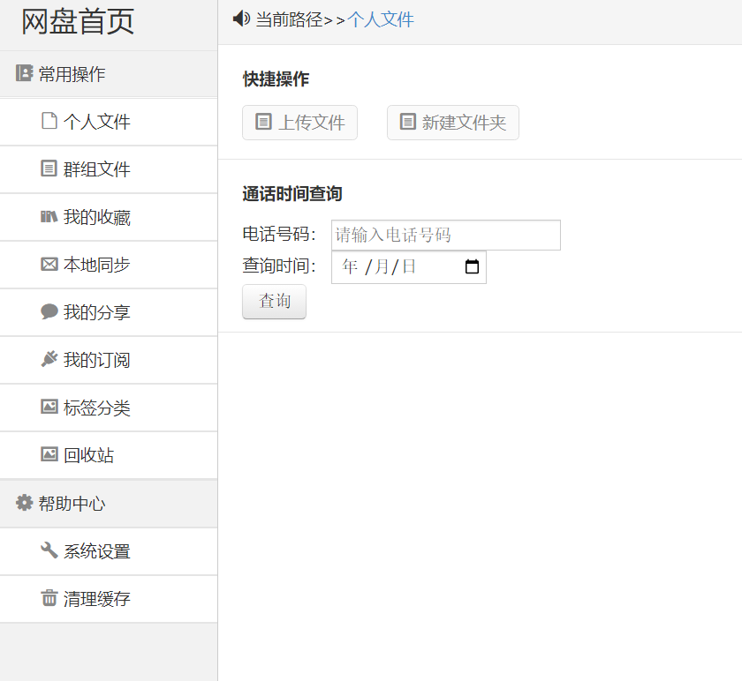

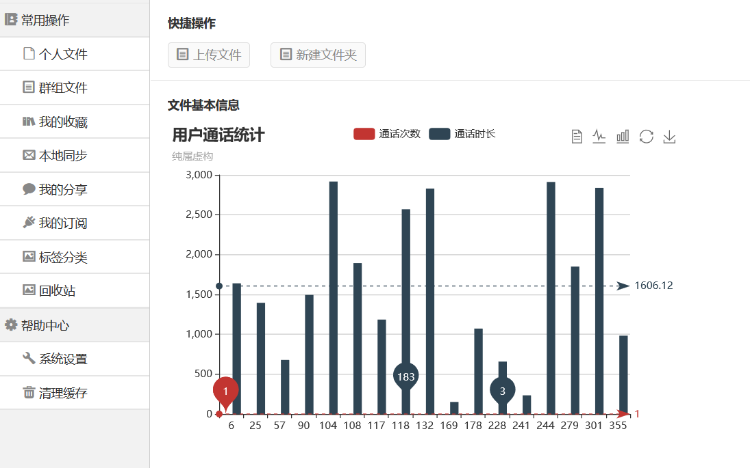

## 项目总结

**出现的问题：**MapReduce任务执行成功，但是MySQL中未插入数据，同时查看MapReduce8088端口，看不到日志，显示no log for container available。  
**问题分析：**  
1.观察MapReduce的任务，发现Reduce的确是正确输出了字节，但是MySQL没有插入数据，那只可能是编写的OutputFormat出现了问题。  
2.no log for container available， 在网上查阅资料提示有可能是内存不足的问题。  
3.查看MapReduce的Reduce任务，发现是在nodemanager是在slave1上运行，而slave1只分配了2G内存。

这个流程是我学习最多的流程，除了复习这个大数据框架的API，更多的是对我的Java有了更多的拓展。除了上述提到的，还有一些注解，泛型和泛型的PECS原则等等。另外就是学习怎么一步步排除错误和寻找自己的错误的方法了，这种DeBug的方式对于我来说很新鲜这是我的一个学习上手的大数据项目，虽然简单但是也学习不少。

**致谢**

要特别感谢指导教师杨中杰老师。在他的悉心指导和热情帮助下成功的完成了此次项目设计和实训报告，老师的认真和负责，给了我们很大的帮助，使我们专业技能的应用水平得到很大提高。同时，老师认真负责的态度，也深深地影响着我们，他细心而又耐心地辅导，使我们顺利完成此次实训报告。